NEWSWATCH



**Vol. 2017-2018 No. 2 September 2017**

**_________________________________________________________________________________­­­­­­**

**Next meeting: 2 p.m., Wednesday, October 11**

**Kelley Dining Room, DeVault Alumni Center, 1000 E. 17th St. (new venue)**

**Ripped from the headlines: Rob Stone**

**to discuss health care reform**

At the next meeting of the IU Retirees Association, **Rob Stone,** M.D., will address the timely topic “Health Care Reform: Disaster or Opportunity?” The meeting will begin at 2 p.m. Wednesday, Oct. 11, in the Kelley Dining Room of the Virgil T. DeVault Alumni Center.



Dr. Stone is director and founder of Hoosiers for a Commonsense Health Plan. He is state coordinator in Indiana for Physicians for a National Health Program and national coordinator for the Divestment Campaign for Healthcare.

An Evansville native, Dr. Stone is a Phi Beta Kappa graduate of Dartmouth College. He graduated from the University of Colorado Medical School in 1977. Dr. Stone is associate director of IU Health Bloomington Hospice and medical director of the palliative care program. In an April appearance before retirees, he outlined choices when the end of life approaches.

“We can park in the Blue Lot across from the DeVault Center or in the Orange Lot on the west side of Assembly Hall (between Assembly Hall and Memorial Stadium),” says IURA Vice President **Doug Porter**. “An Athletic Department building project means both lots will be more congested than in the past.”

**Retirees hear inside scoop**

**for IU’s bicentennial in 2020**

Some 88 IURA members enjoyed reconnecting with each other after the summer break at the Sept. 13 luncheon meeting. **Kelly Kish**, director of the IU Office of the Bicentennial, demonstrated her knowledge of the university’s history as well as her enthusiasm for the upcoming celebrations.

The organizers plan to conduct the many history projects, symposia, lectures, and celebrations using existing university structures, rather than creating a centralized operation that would need to be dismantled after 2020. The planners are approaching the bicentennial as an opportunity to recognize and strengthen IU as a “common good,” building on the ideas of IU’s Nobel Prize winner Elinor Ostrom. Kish noted that IU is the 15th oldest public university in the U.S. and third oldest among the Big Ten.

Terry Clapacs’ book from the IU Press, *Indiana University Bloomington: America’s Legacy Campus* will be released in October. The book describes the campus as a testament to careful planning and committed stewardship. It is one of more than 30 titles the Press will publish as part of the bicentennial.

In 1880 David Starr Jordan offered what is arguably the first U.S. study abroad summer program, with students and faculty making a biking tour of Europe. The 2020 Grand Expedition will re-create the event, with an alumni travel tour, a student summer abroad program, and a hiking, biking, and kayaking tour.

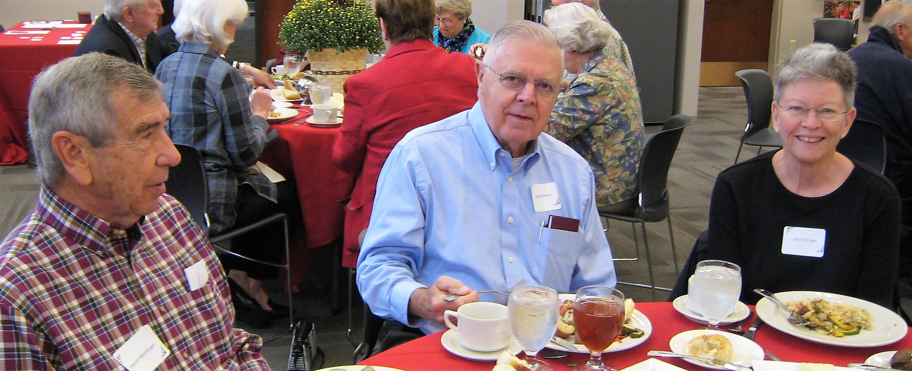

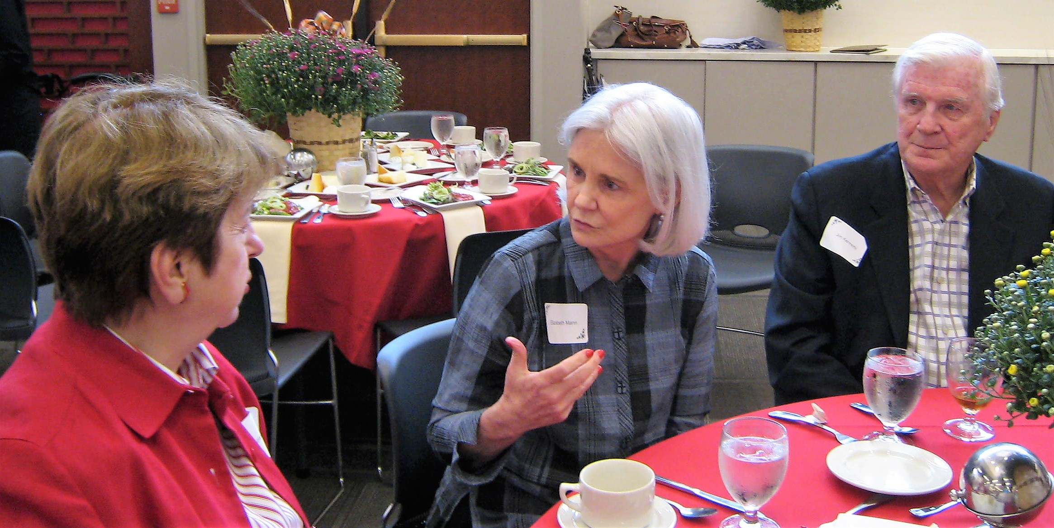 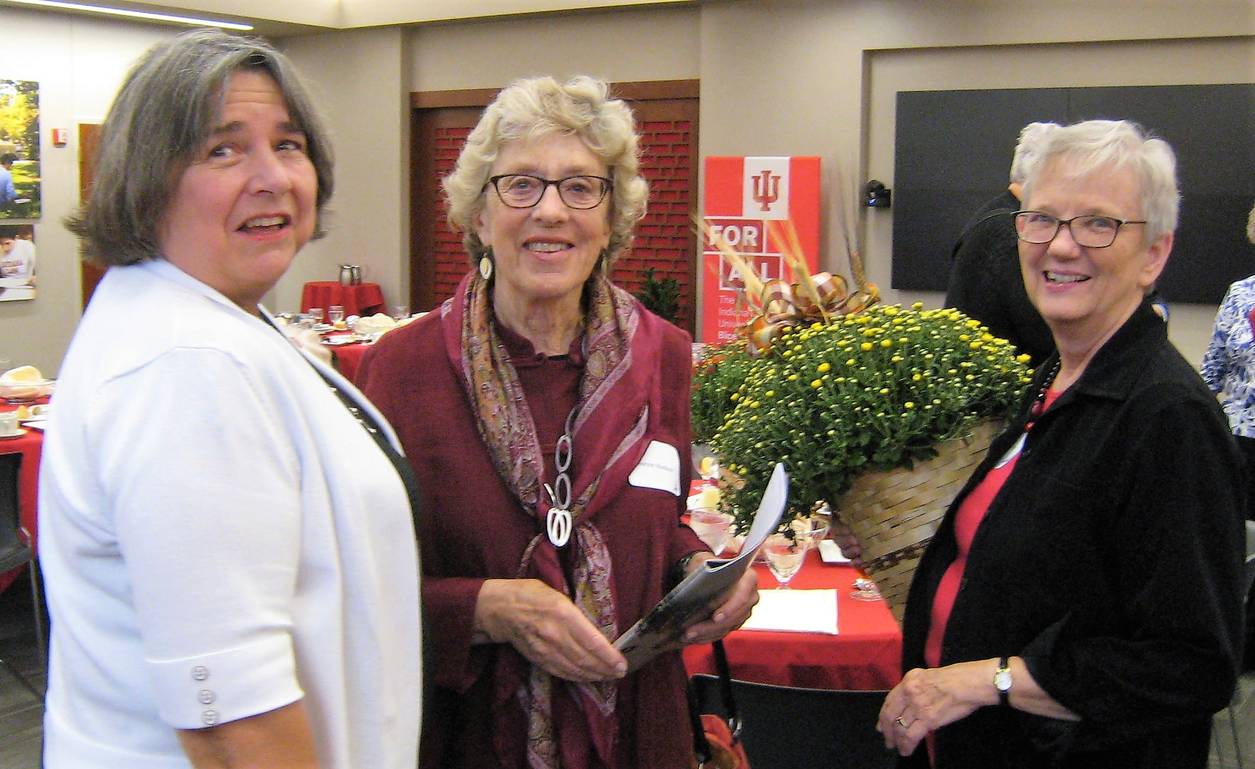**IURA members enjoyed catching up at the September luncheon. Top: Howard Mehlinger, Gerald Marker, and Laura Ginger. Middle: Suzann Owen, Elizabeth Mann, and Jim Kennedy. Bottom: Jeane Novotny, Jeanne Madison, and Glenda Murray.**

IU extends well beyond Bloomington, however. Kish noted that the number of students at non-Bloomington campuses first exceeded the

number at Bloomington in 1930. Using the line “Your story is the story of Indiana University,” the bicentennial planners hope to extend the IU narrative beyond the perspective that the university’s history begins and ends with Herman B Wells and Alfred Kinsey. Plans for connecting IU to the state more broadly include a traveling exhibit of IU objects to go to every county. The 16 items in the exhibit will be “crowd sourced” through student voting among 64 nominated artifacts.

In 2018 IU will host a national symposium on the 60th anniversary of the Higher Education Act, Title VI, which supports higher education in area/international studies and world languages. A Global Alumni Reunion in 2020 will turn the tables on alumni chapters. Instead of creating local events, alumni from around the world will be invited back to the Bloomington and Indianapolis campuses for special events and symposia. The university will also award Bicentennial Medals, incorporating metals from the old Student Building bells.

**Kayla McCarthy**, one of the bicentennial interns, reported on her project, “IU and the American Presidency.” In 1915 President Taft came to Bloomington to give the Founders Day address. Three years later Theodore Roosevelt was the commencement speaker. IU President William Lowe Bryan and students visited the White House in 1922 to use the radio station in the Post Office to call for contributions in memory of World War I soldiers. The response provided funding for the football stadium, Memorial Hall, and the Indiana Memorial Union. McCarthy has created a timeline showing IU connections with presidents from James Madison to Barack Obama linked from the IU History page at <https://200.iu.edu>.

Fundraising is an important part of the bicentennial, Kish noted. Faculty and retirees are responding well to the Bicentennial Campaign Matching Program. President McRobbie will report on progress in his State of the University address. A special bicentennial project, which depends on securing external funding, is a Museum of IU to provide archival quality storage and displays for many university historic materials.

The Jan. 20 Founders Day in 2020 will also be Martin Luther King Jr. holiday. The planning committee hopes to mark the occasion with a very special lecture. Barack and Michelle Obama have been invited for the event. The bicentennial will conclude with a gala on June 6, 2020.

*-- Ralf Shaw, IURA Secretary*

**Big Ten retirees share best practices**

I'm sure you are familiar with the book *Where's Waldo*. Applying that concept to a visit I recently made, can you guess where I was? Here are some clues.

* I sat in an aeronautical simulator.
* I met an astronaut.
* Along with others, I rode in the Boilermaker locomotive.

OK, I know you have guessed: Purdue.

On your behalf, I attended the conference of Big Ten Retirees Associations. All attended but Rutgers. Maryland attended even through it does not have an organization. It is actively working on establishing one.

We are similar and different. Some receive significant support from their university administrations. Some do not have dues, and some receive free parking -- much to the disgust of the rest of us. In fact we requested that they not mention it further. Several have programming similar to our University Club’s. Most of us have close relationships with Human Resources, and one is a constituent group within the alumni association.

While we do not enjoy free parking, we are fortunate to be able to meet in the beautiful IU Foundation, which does provide us with parking. We are grateful. Next year's meeting will be at Penn State.

*-- Joan Benavole Curts, IURA President*

**Schellhammer joins United Way team**

The IURA welcomes **Harriet Pfister** as the new chair of our United Way Committee. **Eileen Schellhammer** will also serve. At the Sept. 13 meeting Harriet thanked **Doris Burton** for her years of service and also **Wain Martin**, who prepared this year’s campaign letter before handing over the reins. The IURA goal for 2018 is $175,000, a 3 percent increase over last year.

*-- Ralf Shaw, IURA Secretary*

**Hustad explains what dues pay for**

Once a year, according to its bylaws, the IURA announces its financial condition to its members. According to IURA Treasurer **Tom Hustad**, as of Sept. 6, the balance in the checking account is $6,195.09. With membership dues still coming in, that amount should be sufficient to pay for the association’s major expenses: renting a post office box, giving modest gifts to presenters, sending a

representative to the Big Ten conference, helping to support the Emeriti House art exhibit, furnishing meat and wine for the May potluck, and – by far the largest expense – printing and mailing the newsletter

and membership directory. The IURA is entirely self-supporting, Tom points out. Founded in 1975 as the IU Annuitants Association, the IURA welcomes all

retired faculty and staff and their spouses or partners.

*Editor’s note: Tom made a cameo appearance in* The Good Catholic*, the recent motion picture filmed in Bloomington. I also spotted* ***Rosemary and Dick Dever*** *playing bingo. Did any other IURA members participate?*

**- - - - - - - - - - - - - - - - - - - - - - - - - - - - - - - - - - - - - - - - - - - - - - - - - - - - - - - - - - - - - - - - - - - - - - - -**

**IU Retirees Association**

**2017-2018 MEMBERSHIP FORM**

Name_______________________________________________________________________

For couple membership, spouse’s/partner’s name____________________________________

Address ____________________________________________________________________

City ____________________________State______9-digit ZIP code____________________

Telephone­* ______________________E-mail* ____________________________________

*Telephone number and e-mail will be included in membership directory only if you write them here.

Enclosed is my check, made payable to IU Retirees Association, for:

__________Single membership ($15) __________Couple membership ($20)

Please mail this form with your check to IU Retirees Association

P.O. Box 8393

Bloomington, IN 47407-8393

____ I wish to receive the newsletter by e-mail rather than in paper form.

**IU Retirees Association Nonprofit Org.**

**P.O. Box 8393 U.S. Postage PAID**

**Bloomington, IN 47407-8393 Bloomington, IN**

**Permit No. 2**

**A peek at coming IURA attractions**

**https://www.exchange.iu.edu/owa/14.2.247.5/themes/resources/clear1x1.gifhttps://www.exchange.iu.edu/owa/14.2.247.5/themes/resources/clear1x1.gif**Here are some dates for your calendar:Thanks you Dick I think that is a good suggestion about listing topics. It may generate some more ideas. Thank you and your cmmittee for getting this going. I'm out of town July 12 until July 19 but am accessible at leat by cell phone 812-325-4348 and infrequently

* Thu 7:37 AM
* Nov. 8 at 2 p.m., **Robin Reynolds,** H.R. program on retiree benefits
* Dec. 13, holiday luncheon with Music Warehouse show choir from Edgewood High School

### Jan. 10 at 2 p.m., Matt Bailey, president, IU Health South Central region, update on IU Health Bloomington Hospital

* Feb. 14 at 2 p.m., TBA
* April 11 at 2 p.m., physicist **Ben Brabson** on climate change
* May 9 at 5 p.m., dinner at Meadowood, with **Charlie Jesseph**, guitar

Ifkiesling

Thanks you Dick I think that is a good suggestion about listing topics. It may generate some more ideas. Thank you and your cmmittee for getting this going. I'm out of town July 12 until July 19 but am accessible at leat by cell phone 812-325-4348 and infrequently

Thu 7:37 AM

**Why am I getting this newsletter?**

You are getting this newsletter for one of two reasons. Database manager **Doris Wittenburg** maintains a Big List with more than 994 names:

1. IURA members, 258 at last count, pay the costs of printing and mailing *Newswatch* in hopes that others will join (see form on reverse side). Members who have signed up for email delivery are receiving a printed copy this month while the email list is being developed.

2. Prospective members who do not join or renew their membership will receive the newsletter through October.

If you have not paid dues for this year, this is your next-to-last newsletter. You can check your membership status on your address label. If you wish to correct your address or remove your name from the list, send a message to Doris at [dwittenb@indiana.edu](mailto:dwittenb@indiana.edu) with “unsubscribe” in the subject line and your name as it appears on IU records.

**Judy Schroeder** edits *Newswatch* eight times a year, August through April, except for February. Please send corrections and comments to her at [jschroed@indiana.edu](mailto:jschroed@indiana.edu).