NEWSWATCH



**Vol. 2016-2017 No. 2 September 2016**

**_________________________________________________________________________________­­­­­­**

**Next meeting: 2 p.m., Wednesday, October 19 (NOT Oct. 12)**

**Kelley Dining Room, DeVault Alumni Center, 1000 E. 17th St. (NOT IU Foundation)**

**Deans to discuss changes in student life**

At the October meeting of the IU Retirees Association, three deans of students will address the topic “Changing Times: Three Deans’ Perspectives on Trends in Student Life Over the Past 50 Years.”

The meeting will begin at 2 p.m. Wednesday, Oct. 19, in the Kelley Dining Room of the Virgil T. DeVault Alumni Center. Pl

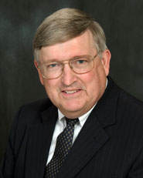Panelists will be **Dick McKaig**, **Harold “Pete” Goldsmith**, and **Lori Reesor**. Each has headed the Division of Student Affairs, which has 13 departments and more than 150 programs that serve domestic and international undergraduate and graduate students.

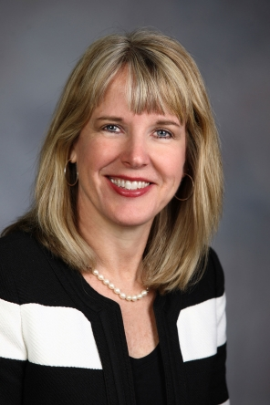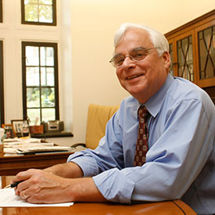Dick McKaig (above left) began working with students at IU in 1971. He became dean of students in 1991 and retired in 2009. Pete Goldsmith (above right) worked more than 35 years in higher education administration at seven universities. He served as IU’s dean of students from 2009 to 2016. The newest dean of students and vice provost for student affairs is Lori Reesor, who came to IU in July from the University of North Dakota. She has more than 30 years’ experience in student life at five universities.

Parking is available, free of charge, in the lot directly opposite the DeVault Alumni Center on 17th Street.

“The meeting originally was scheduled for Oct. 12,” says IURA President **Joanie Curts.** “But when **Susan Klein** pointed out a conflict with the Jewish holiday of Yom Kippur, we changed the meeting to the following week. We expect a large turnout because of the panel and the topic.”

**Hamilton encourages retirees to assist**

**In development of Comprehensive Plan**

“If you want to build a great city, create a great university and wait 200 years.” When he spoke to more than 100 retirees on Sept. 14 at the IU Foundation’s Peterson Room, Bloomington Mayor **John Hamilton** cited this apt quotation from Daniel Moynihan.

Safety, affordable housing, public transportation, the environment: Hamilton spoke to all these issues and more. The 2040 Comprehensive Plan now under review addresses these subjects, and the mayor encouraged retirees to read and offer input to the plan, a roadmap to Bloomington’s future: https:// bloomington.in.gov/cmp. The plan will be reviewed first by the city plan commission and then by the city council before it is approved.

The city’s population has grown from about 52,000 in 1980 to 83,000 in 2014, Hamilton told retirees. Students make up half the population. While 5,700 people commute out of Monroe County, 15,000 commute into it, making the delay in completing I-69 particularly problematic. “The road from here to Martinsville was supposed to be done by next month,” Hamilton said. “Now it will be at least next summer before it’s done.”

Public transportation has risen from under 500,000 riders in 1984 to more than 3.5 million in 2015. The number of riders is the highest per capita in Indiana, he said. The trail system has also grown:

* 1988 Bloomington Rail Trail
* 2003 Clear Creek Trail
* 2011 B-Line and Jackson Creek Trails
* 2014 Cascades Park Trail

Affordable housing is one of the mayor’s priorities. “Bloomington is the most expensive rental market in the state,” Hamilton said. One reason: In most cities one-third of the population are renters while two-thirds own their homes. The situation in Bloomington is the reverse, with two-thirds of the population renting homes. Hamilton said he will continue to encourage inclusionary zoning, which requires that a small number of units in new apartment buildings must be permanently affordable.

Crawford Apartments, which is supported primarily by federal funds, provides housing for the most disabled and chronically homeless. Since its opening in 2013, its 20 long-term residents have made 80 percent fewer visits to the emergency room and spent two-thirds less time in jail.

Mental illness, drug addiction, and poverty all are factors in homelessness. Hamilton pointed out that 40 percent of homeless people are families with children. It is important to differentiate homelessness and panhandling. “Most panhandlers are not homeless,” he said. “They do it because they make money.”

The safe, civil, and just city initiative launched in August was formed because violent crime in Bloomington is trending up. “If people don’t feel safe, they can’t enjoy what’s going on in their community,” Hamilton said. He has asked Bloomington police chief Mike Diekhoff to increase policing in downtown public spaces.

Retirees invited the mayor to “talk trash.” The city has a 1950s sanitation system, Hamilton said. Automation will reduce injuries workers incur from manually lifting heavy garbage cans.

The mayor addressed numerous questions from the audience, including urban deer. Insofar as the Griffy Nature Preserve is concerned, Hamilton said, “there is significant scientific evidence that deer are damaging it. I will follow the science to preserve the preserve.” As for urban deer, neighborhoods differ in whether they consider deer a problem and, if so, how the problem should be addressed. One thing is clear, he said: “Urban deer are very happy.”

In introducing the mayor, IURA Vice President **Doug Porter** said, “Discussion of parking meters is nonessential.” When he took office, Hamilton said, he found that downtown parking meters had a 250 percent annual failure rate. In less than a year the failure rate has been reduced to acceptable levels.

Because his wife is an IU faculty member, Hamilton considers himself a future member of the IU Retirees Association. A strong advocate for public schools, he urged retirees to support the referendum when they vote in November.

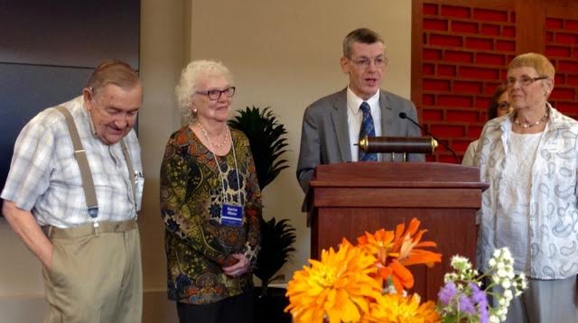

**Community investors: from left, Wain Martin, Harriet Pfister, Barry Lessow, Doris Burton**

**United Way honors IURA’s generosity**

At the Sept. 14 meeting **Barry Lessow**, executive director of United Way of Monroe County, presented the IURA with the Community Investment Award, honoring the organization’s phenomenal performance in the 2015 United Way campaign. “We thought the $145,000 goal would be hard for this group to reach, but the IURA raised $176,333.34,” Barry said. “I used the 34 cents to buy suspenders like Wain’s,” he added in jest.

He was referring to **Wain Martin**, part of the IURA triumvirate that has headed the IURA’s United Way effort for longer than any of them can remember. **Harriet Pfister** and **Doris Burton** are the other two stalwarts. In the October *Newswatch* they will provide members with information about the 2016 United Way campaign.

**Big Ten retirees share best practices**

There are significant holes in my travel life, one being the central United States. From Aug. 5 to 7 I attended the Big Ten Retirees Conference, which this year was in Lincoln, Neb. I found Lincoln to be delightful. We had fabulous weather and accommodations were lovely.

Part of our itinerary included sessions on creative aging and dealing with those concerns. We had interesting tours of the University of Nebraska, which is a land grant school. Interesting to me was an incredible Natural History Museum with relics of the long past -- elephants and camels, oh my! We had lunch at the football stadium and a lovely dinner at the International Quilt Center.

We included representatives from all Big Ten (14) universities except Maryland, which does not have a retiree group.

Exchanging ideas for programming and purposes was especially interesting. We are much the same, but

some have interest groups similar to our university club. Nebraska includes only faculty and administrators in membership. Ohio State will become a constituent group within the alumni association. All have benefits programs, and some have an annual benefits meeting.

It was a great time, educational, productive and entertaining. Next year's meeting will be up the road at Purdue.

* *Joanie Curts, 2016-17 IURA President*

**Remembering Sam Bell: letter to editor**

After his recent death, **Sam Bell** justly received many accolades concerning his illustrious career as a track coach at IU. But none of these tributes mentioned the fact that, despite having serious heart surgery, Sam accomplished a great deal after he retired. As noted in the August *Newswatch*, Sam served on the board of what was then called the Annuitants Association (now the IU Retirees Association) and was its president in 2002-2003.

He befriended me and other members of the association with his many kindnesses and support. I was secretary of the organization, and one of my

**- - - - - - - - - - - - - - - - - - - - - - - - - - - - - - - - - - - - - - - - - - - - - - - - - - - - - - - - - - - - - - - - - - - - - - - -**

**IU Retirees Association**

**2016-2017 MEMBERSHIP FORM**

Name_______________________________________________________________________

For couple membership, spouse’s/partner’s name____________________________________

Address ____________________________________________________________________

City ____________________________State______9-digit ZIP code____________________

Telephone­* ______________________E-mail* ____________________________________

*Telephone number and e-mail will be included in membership directory only if you write them here.

Enclosed is my check, made payable to IU Retirees Association, for:

__________Single membership ($15) __________Couple membership ($20)

Please mail this form with your check to IU Retirees Association

P.O. Box 8393

Bloomington, IN 47407-8393

____ I wish to receive the newsletter by e-mail rather than in paper form.

**IU Retirees Association Nonprofit Org.**

**P.O. Box 8393 U.S. Postage PAID**

**Bloomington, IN 47407-8393 Bloomington, IN**

**Permit No. 2**

duties was to assemble the monthly newsletter. I especially remember the hard time one committee member gave me because I was not using the style she thought I should use. Sam was very supportive of me in working through that problem.

Sam also made a point of going to the annual conference of retiree associations of Big Ten universities. I went with him to the conference at the University of Michigan. An old friend from track coaching days was there. His nickname was “Red,” but I do not recall his last name. Red must have been approaching 100 years at that point but was very agile. I still use some of the exercises that the fitness specialist recommended at that session.

Those were wonderful times in Sam’s life and for those who interacted with him. They should be remembered as part of the last chapter of his long and very productive life.

* *Bob Dodd*

**Put these dates on your calendar now!**

**https://www.exchange.iu.edu/owa/14.2.247.5/themes/resources/clear1x1.gifhttps://www.exchange.iu.edu/owa/14.2.247.5/themes/resources/clear1x1.gif**

Ifkiesling

Thanks you Dick I think that is a good suggestion about listing topics. It may generate some more ideas. Thank you and your cmmittee for getting this going. I'm out of town July 12 until July 19 but am accessible at leat by cell phone 812-325-4348 and infrequently

Thu 7:37 AM

Nov. 9 at 2 p.m., **Teri Moren**, IU women’s basketball head coach

Dec. 14, holiday luncheon with the Singing Hoosiers

Jan. 11 at 2 p.m., **David Brenneman,** director of the IU Art Museum

Feb. 8 at 2 p.m., Jacobs School of Music Professor **Glenn Gass**

April 12 at 2 p.m., **Dr. Rob Stone**, medical director of IU Health’s palliative care program

May 10 at 5 p.m., the annual potluck dinner, with **Randy White** of Cardinal Stage

**Basketball fan? Volunteer at Cook Hall!**

Do you enjoy talking about Indiana basketball and sharing your passion for everything that is IU? Cook Hall offers a great volunteer opportunity at the welcome center. Serve as a front desk greeter for Indiana men’s and women’s basketball. Please contact **Kurt Pangborn** at (812) 855-9370 or by email at kpangbor@indiana.edu for more information or to schedule a visit.​

**Why am I getting this newsletter?**

You are getting this newsletter for one of two reasons. Database manager **Doris Wittenburg** maintains a Big List with more than 1,000 names:

1. IURA members, 282 at last count, pay the costs of printing and mailing *Newswatch* in hopes that others will join (see form on reverse side). Members who have signed up for email delivery are receiving a printed copy this month while the email list is being developed.

2. Prospective members who do not join or renew their membership will receive the newsletter through October. If you have not paid dues for this year, this is your next-to-last newsletter. If you wish to remove your name from the list, send a message to Doris at dwittenb@indiana.edu with “unsubscribe” in the subject line and your name as it appears on IU records.

**Judy Schroeder** writes *Newswatch* eight times a year. Please send corrections and comments to her at jschroed@indiana.edu.