NEWSWATCH



**Vol. 2017-18 No. 6 January 2018**

**________________________________________________________________________________**

**Next meeting: 2 p.m., Wednesday, February 14**

**Peterson Room, Showalter House, IU Foundation, SR46 Bypass**

**The Peace Corps then and now:**

**Millers to recall Nigeria in the ’60s**

It’s altogether fitting and proper when a meeting falls on Valentine’s Day to hear from a couple who have weathered more than 50 years together, after what many considered an ill-advised adventure. Peace and esprit d’corps will be the subject when retirees gather in the Peterson Room at the IU Foundation on Feb. 14.

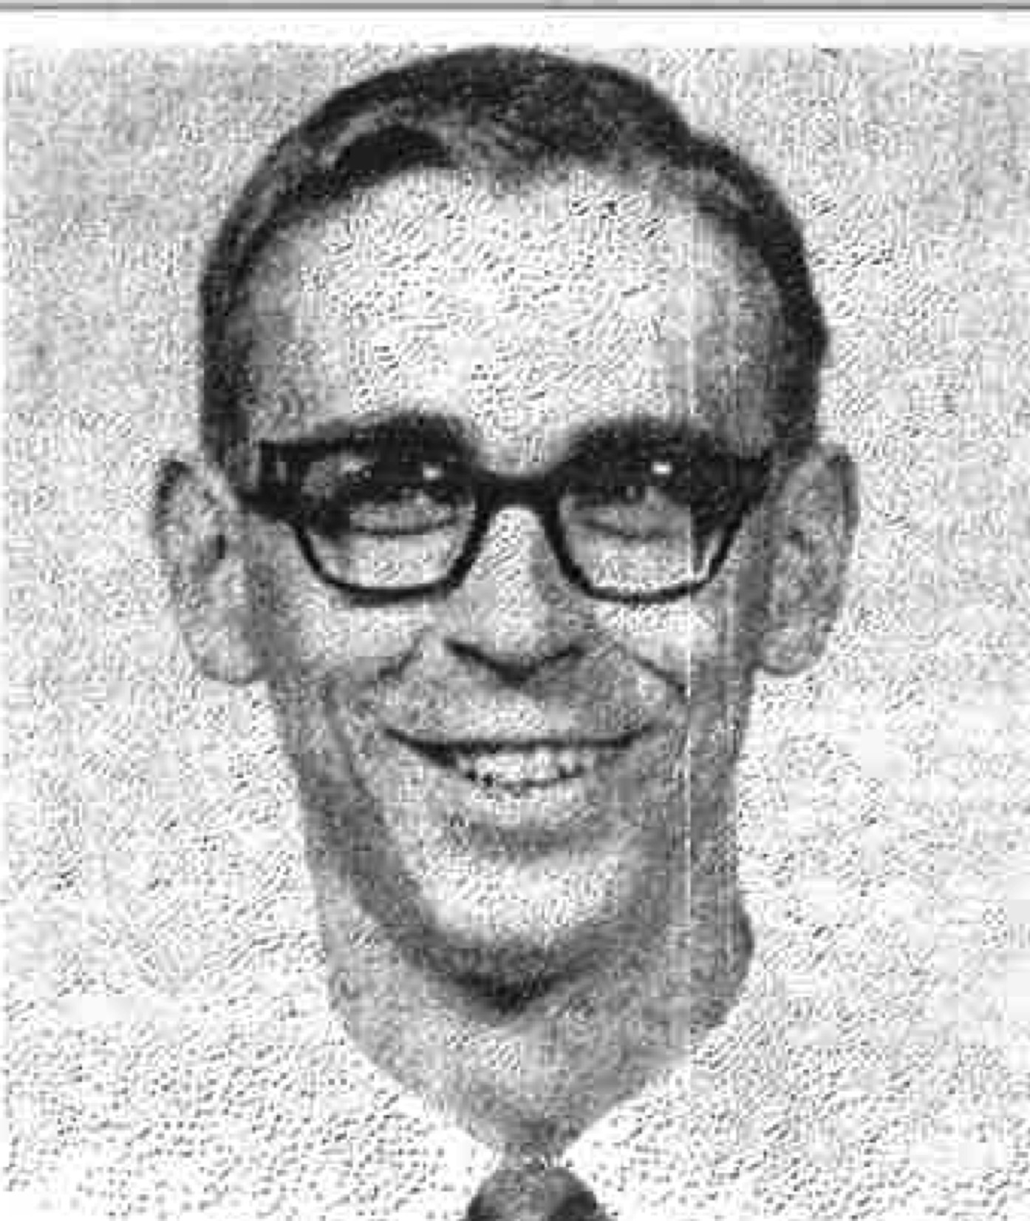In June 1963 **Ruth** and **Joe Miller** were among 176 young people entering Nigeria as Peace Corps volunteers. The Millers had married in August 1961, the same month and year that the very first Peace Corps volunteers left for Ghana and Tanzania, the first two countries to welcome the brand-new program.



**Ruth and Joe Miller in 1963. Asked for a current photo, Ruth said it’s not necessary: “We’ll be there in person.”**

During their two years in the Peace Corps, they would fight spitting cobras and malaria, have their first baby, travel to see camel trains at the edge of the Sahara Desert -- all while Joe lectured in law and Ruth in French at the University of Nigeria. The Millers also will discuss how well the Peace Corps has achieved its objectives over its 57-year history. Ruth retired as associate director of IU’s International Services, and Joe is professor emeritus of marketing in the Kelley School of Business.

**Retirees use golden years to follow Golden Rule, give back to others**

*Life’s most persistent and urgent question is, “What are you doing for others?”*

*-- Martin Luther King Jr.*

It’s quite incredible. Once again retirees have gone above and beyond in supporting their community. At the Jan. 10 meeting **Eileen Schellhammer** and **Harriet Pfister** announced that as of Jan. 9 retirees have pledged $243,572.90 to the 2018 United Way campaign, achieving 116 percent of the $210,000 goal. As of Jan. 9 there were 233 retiree donors, including 104 Vanguards, those pledging $1,000 or more.

Every year United Way sets the goal higher, and every year retirees exceed it. The record speaks for itself:

**Year** **Goal**  **Raised** **Contrib.** **Vanguards**

2018 $210,000 $243,573 233 104

2017 $170,000 $174,367 203 79

2016 $145,000 $172,503 201 79

2015 $135,000 $153,000 195 69

2014 $125,000 $131,773 161 62

2013 $115,000 $137,000 224 64

2012 $100,000 $115,000 161 62

It’s not just money. Go to almost any United Way agency and you’ll find retirees performing yeoman duty: preparing food at Community Kitchen, delivering meals at Meals on Wheels, working at Opportunity House, serving as VITAL volunteers. Retirees and their spouses also sit on boards of directors. The following list may be exhausting but it’s not exhaustive:

**Janice Wiggins** serves on the Area 10 Agency on Aging board.

**Jack Mulholland** is treasurer of the Meals on Wheels board, of which **Barbara Weinberg** is also a member.

**Sally Dunn** is secretary of the Middle Way board, on which **Janet Stavropoulos** and **Carl Ziegler** also serve.

**Jackie Hall** is vice president of the board of Monroe County United Ministries.

**Judy Simic** is on the board of the Shalom Community Center.

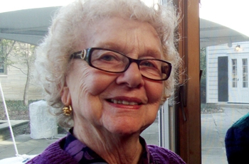

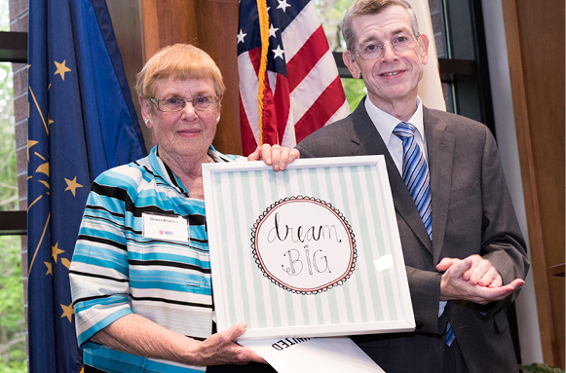**“With kindness and a smile, Harriet Pfister brightens the day and lightens the load of those around her.” So begins a recent Live United spotlight.**

**Doris Burton was honored with the 2016-17 Mary Alice Gray Memorial Award for extraordinary volunteer service. Doris joined the UW board in 1999.**

And it’s not just United Way agencies. Retirees have little time to enjoy the rocking chair in the IURA logo. They volunteer for arts, religious, and fraternal (and sororal) organizations. They’re involved in political and social action organizations, in community and neighborhood committees and associations. Three examples:

**Gail Londergan** is a member of the City of Bloomington Commission on Aging.

**Fred Risinger** is secretary of the board of trustees for the Monroe County Public Library.

**Susan Jones** is secretary and **Harlan Lewis** treasurer of the board of directors of Bloomington Playwrights Project. **Marty Joachim** and **Saundra Taylor** serve on that board.

Hats off to *all* who give of their time and money in the service of others.

**Add these names to your IURA directory**

IURA database manager Doris Wittenburg compiled the 2017-18 IURA directory. With listings for 421 members, it was mailed with the December *Newswatch*. Information for the following people was received too late for inclusion. Please add to your directory:

**Martin and Barbara Burkhead**

618 S. Eastside Drive

Bloomington 47401-5257

812-336-3612

burkhead@indiana.edu

**Olga T. and Michael H. Impey**

1033 S. Hawthorne Drive

Bloomington 47401-6090

**Audrey and Michael Morgan**

P.O. Box 5546

Bloomington 47407-5546

amorgan@indiana.edu

**Kenneth V. Nelson**

4702 Dundee Drive

Bradenton FL 34210-2900

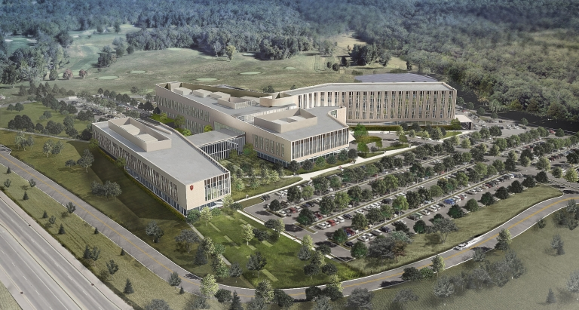

**James (Jim) O. and Chris Woods**

122 Shadeland Drive

Bloomington 47403-2867

812-272-2361

Three email addresses need addition or correction:

**Robert Agranoff**

[agranoff@indiana.edu](mailto:agranoff@indiana.edu)

**Devonia Stein**

[devsstein@alumni.iu.edu](mailto:devsstein@alumni.iu.edu)

**Susan Stryker**

[sstryker@indikana.edu](mailto:sstryker@indikana.edu)

**New hospital: A perfect storm or a transformational opportunity?**

**Matt Bailey**, president of IU Health South Central Region, described his goal for the new regional academic health campus that is just breaking ground. Speaking to 75 retirees at the Jan. 10 meeting of the IURA, Bailey said his goal is to create “a sanctuary of learning and healing.” The primary consideration in planning the new building, he said, “is to remove barriers to make it easier to navigate in a very fragmented environment.”

The Bloomington hospital has been part of the community for 113 years. The third largest employer in the county, it comprises one-sixth of the Monroe County economy. But Bailey pointed out that more than half its patients come from outside Monroe County. IU Health South Central Region has 5,000 team members, including more than 350 medical providers, serving 470,000 residents in 11 counties. A Level III trauma center, it has been given a five-star rating by CMS (Centers for Medicare and Medicaid Services).

The building, Bailey said, will be “a wonderful enabler” of high-quality medicine. Clinical care, education, and research facilities will be in one location. “Right now,” Bailey said, “diagnostics are all over the place. Now they will be under one roof.” The goal, he said, is “to look at health care as a total rather than an episodic system.”

The photo above shows the entire 700,000-square-foot campus. The education portion is at the left. A cafeteria links the academic and medical portions of the complex. The long middle section is the outpatient area, with the cancer center entrance at one end and the clinic at the other. To the right is the hospital itself.

The 115,000-square-foot IU Academic Health Sciences Building, at left, will include classes for students in medicine, nursing, social work, speech and hearing, and a new program in dentistry. Bailey expressed pride that IU Health Bloomington has received Magnet recognition from the American Nurses Credentialing Center, an honor earned by only 10 percent of hospitals and recognizing high-quality nursing.

In the health rankings released in December, Bailey said, Indiana ranked 38th among the 50 states. In infant mortality, cancer deaths, drug deaths, and heart disease, Indiana was in the bottom 10. Many hospitalizations are preventable, the results of obesity and smoking. On the brighter side, Monroe ranks 16th among Indiana’s 92 counties.

The audience peppered Bailey with questions and learned from the answers. The reason for surface parking and a parking garage, for example, is that a surface parking space costs $6,000 and a garage space $16,000. The hospital will have its own storm and sewer system. Currently the emergency room has 55,000 visitors a year. The new emergency room probably will have metal detectors, as is already the case at Riley Hospital.

**IU Retirees Association Nonprofit Org.**

**P.O. Box 8393 U.S. Postage PAID**

**Bloomington, IN 47407-8393 Bloomington, IN**

**Permit No. 2**

Although the IURA meeting was only six days before groundbreaking for the new building, the personable president was generous with his time, staying afterward to answer questions. In introducing the speaker, **Bill McGregor** mentioned that Bailey is from Vincennes, the son of a nurse and the father of a nurse.

Construction of the regional academic health campus is expected to be completed by the fall of 2020. As they sampled cookies provided by **Doris Burton**, **Gail Londergan**, **Carol** **McGregor**, and **Doug Porter**, some retirees were rueful at the emphasis on outpatient care, nostalgic for the old cross-country course, or apprehensive about the prospect of having to learn their way around a new campus. Others, like **Don Granbois**, observed that space and location constrain the current hospital. They are excited about the educational and health care synergies a state-of-the-art facility creates.

**Emeriti House, University Club**

For information about the programs of the Emeriti House and the University Club, our partner organizations, see

http://www.indiana.edu/~emeriti and

<http:///www.indiana.edu/~uclub>.

**Rounding out the 2017-2018 calendar**

* On April 11 at 2 p.m., at the IU Foundation, physicist **Ben Brabson** will speak about climate change.
* Meadowood is hosting the spring dinner on May 9 at 5 p.m., with **Charlie Jesseph** on guitar.
* The IURA does not meet in March.

**Benefits only a click away on webpage**

When retirees gathered on Jan. 10, IURA benefits chair **Bruce Jaffee** paid tribute to the efforts of webmaster **Suzann Owen**. She has posted the recently revised list of benefits, which will be available in printed form at the February meeting, on the IURA webpage. “Clicking on a link is more efficient than typing in a long URL,” Bruce observed.

**About this newsletter**

*Newswatch* is published eight times each year, August through April, except for February. To correct your address, please contact **Doris Wittenburg,** dwittenb@indiana.edu. **Judy Schroeder** writes *Newswatch*. Send corrections or comments to her at jschroed@indiana.edu.