NEWSWATCH



**Vol. 2018-19 No. 5 December 2018**

**________________________________________________________________________________­­­­­­__**

**Next meeting: 2 p.m., Wednesday, January 16, 2019**

**St. Mark’s United Methodist Church, 100 SR46 Bypass (new location)**

**Stafford to explore meaning of home and stuff at January meeting**

What better way to welcome in the new year than by contemplating the meaning of things? **Phil Stafford**, retired director of IU’s Center on Aging and Community, will lead an interactive presentation, “The Meaning of Home and Stuff,” when retirees gather in Garton Hall at St. Mark’s United Methodist Church at 2 p.m. on Jan. 16.

Phil will challenge retirees to evaluate their relationship to things and the implications of that relationship during life’s transitions.

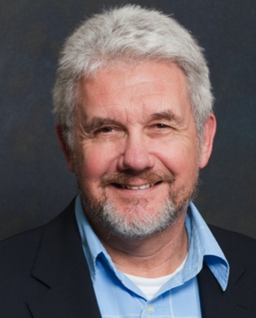For four decades Phil has been active in developing age- and ability-friendly communities. An adjunct professor in IU’s anthropology department, he retired in 2017. A member of the board of the American Society on Aging, he has written multiple articles on aging in place. He chairs the City of Bloomington’s Commission on Aging. In 2014 he was honored with the Ageless America award from Partners for Livable Communities.

A native of Hobart, Ind., Phil holds a bachelor’s degree from the University of Chicago and a Ph.D. in cultural anthropology from IU.

**Holiday lunch spotlights Tallent**

“I planned to die at a very old age behind the stove at Restaurant Tallent,” Chef **Dave Tallent** told retirees gathered for a festive holiday luncheon at the IU Foundation on Dec. 12. But IU offered him the chance to spend fewer 18-hour days and six-day weeks while improving its food service. Because he believed the campus was underperforming in providing local and sustainable food, he joined Traditions Catering, which is now part of IU Dining.

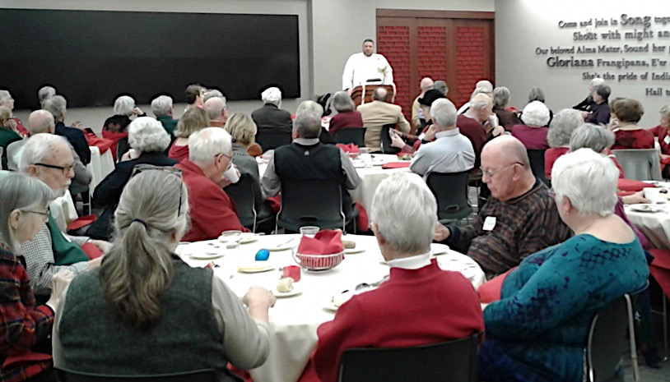

Dave described a win-win situation: IU Dining offers healthy, tasty food in its dining halls and local farmers don’t have to spend so much time marketing their crops. “Hamburger served in any dining hall comes from Fischer Farms,” he said. The proprietor of the farm is on campus every week to ensure quality while at the same time being able to expand into the Chicago market.

Dave said the director of IU Dining shares his goals of local, sustainable food. The IU Campus Farm at the Hinkle-Garton Farmstead on East 10th Street is part of that vision.

“We’re trying every day to do the right thing and not kill the planet,” Dave said. “And we’re going to cook your food as close to the time you’re going to eat it as we can.”

An online tool, NetNutrition, allows students to tailor their food selections to their dietary needs and preferences. This app identifies vegan, vegetarian, and halal options at various IU dining locations and allows those with allergies to know what dishes are safe for them.

“We’ve been sprinting” since IU Dining was created in May, Dave explained. There have been times when a staff of 75 to 80 caters 48 events in one day, 25 off premises.

In introducing Dave, IURA President **Doug Porter** reminisced about meals at Restaurant Tallent, “the finest dining experience in the state of Indiana.” Doug also thanked those involved in planning the meeting and shuttle service.

The luncheon was **Tine Lindemann**’s swan song, and she sang it to perfection. Early next year Tine, co-chair of the IURA hospitality committee, is moving to North Carolina with her husband, **George Malacinski**, to be closer to grandchildren. Other hard-working hospitality committee members are **Sally Dunn**, **Gail Londergan**, and **Charlie Matson**.

**Steve Hitzeman** and **Bill McGregor** served as parking monitors. Shuttle coordinators and drivers included **Tim Londergan**, **Charlie Matson**, **Ellen Porter**, and **Ralf Shaw**. **Joe Miller** and **Doris Wittenburg** assisted with registration.

**Thanks for the hospitality!**

For decades the IU Foundation has offered its facilities free of charge to the IURA and its predecessor organizations. IURA historian **Tom Nisonger** points out that the inaugural meeting of the IU Annuitants Association on Sept. 2, 1975, was at the IU Foundation. Programs were regularly held at the IUF as early as 1980.

In an email to IURA Secretary **Ralf Shaw**, **Matt Kavgian**, director of strategic communications and projects at the IUF, wrote, “To the best of my knowledge, the IURA is the only group among the many we host not charged any fees, due in no small part to the high level of esteem we have for your members.”

But the IUF is experiencing serious parking constraints. The renovation of the IU golf course and construction of its new clubhouse have closed off access to its parking lot. Because parking for employees must have priority, the IUF can allow the IURA a maximum of only 40 spaces.

Although IURA members attending the holiday luncheon expressed their delight with the efficient shuttle service, the board has moved the January and February meetings to St. Mark’s United Methodist Church, which has plenty of parking and is accessible to all.

**Worth a thousand words**

**Ralf Shaw**, **Tine Lindemann**, and **Judy Schroeder** share these photos of celebrants at the holiday luncheon. More on IURA website.

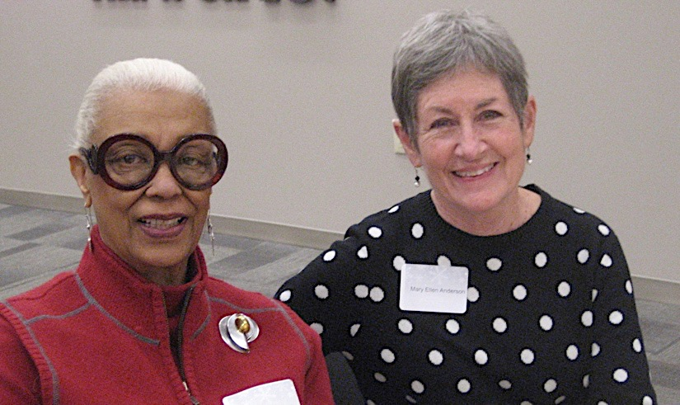

**Carol Stokes and Mary Ellen Anderson are longtime friends.**

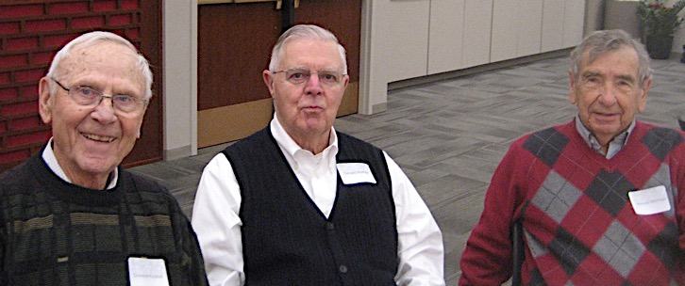

**DeWayne Kurpius, Gerald Marker, and Howard Mehlinger share School of Education memories.**

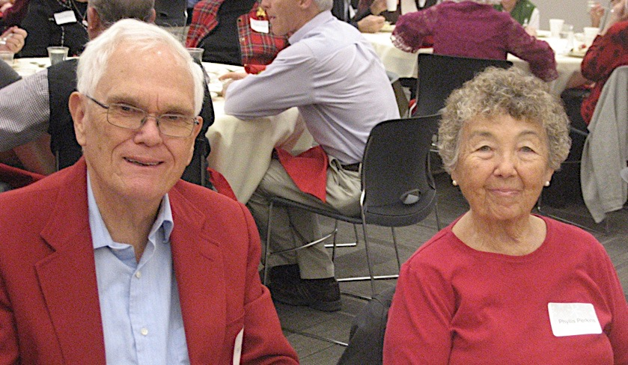

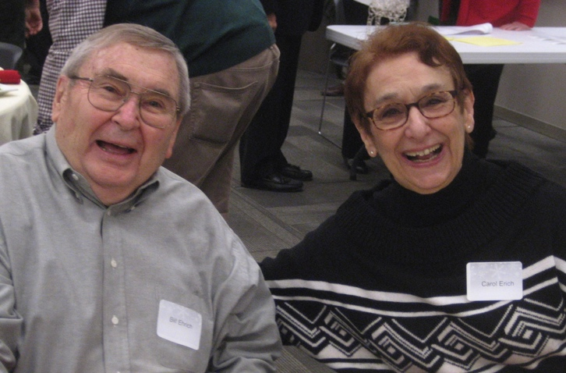

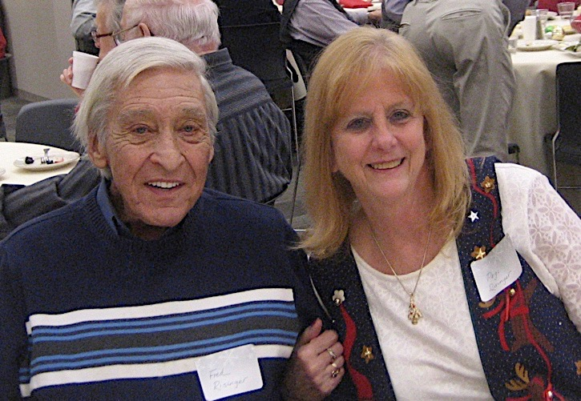

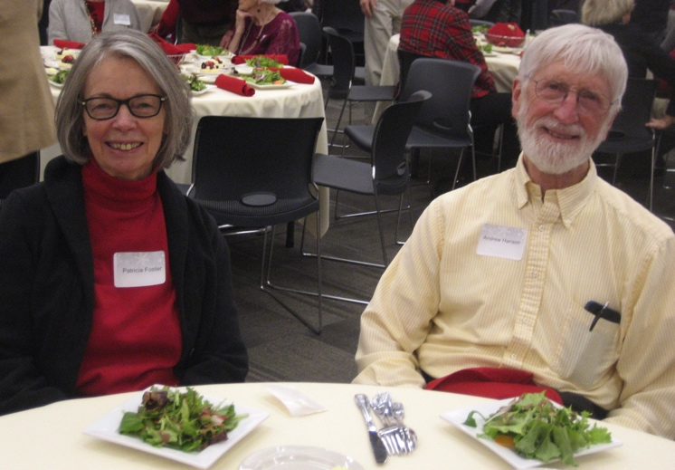

**From top: Bill and Phyllis Perkins; Bill and Carol Ehrich; Fred and Pegi Risinger; Patricia Foster and Andy Hanson**

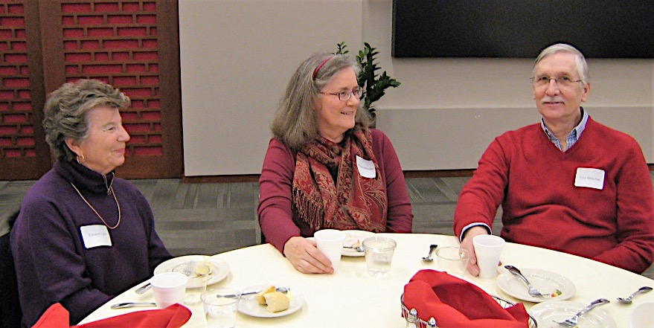

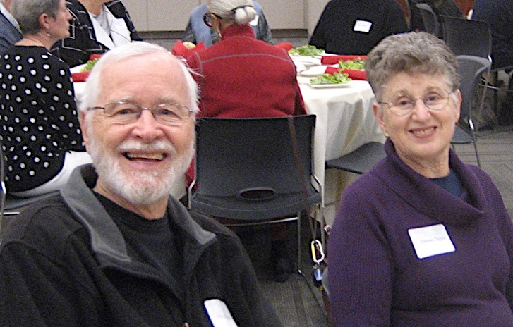

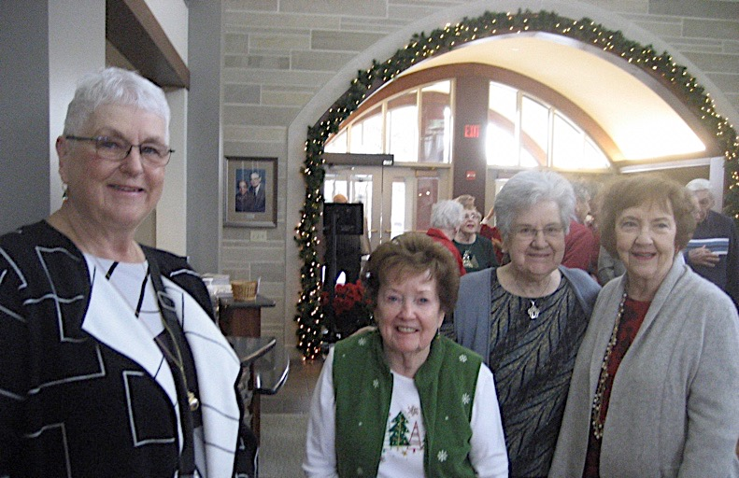



**From top: Eleanor Lahr with Trina and Tony Mescher; Hal and Denise Ogren; Maribeth McKaig, Kate Kroll, Devonia Stein, and Barbara Crowe wait to enter the Peterson Room; the beautiful decorations by Sally Dunn and Tine Lindemann**

**IU Retirees Association Nonprofit Org.**

**P.O. Box 8393 U.S. Postage PAID**

**Bloomington, IN 47407-8393 Bloomington, IN**

**Permit No. 2**

**Emeriti House, University Club**

For information about the programs of the Emeriti House and the University Club, our partner organizations, see

<http://www.indiana.edu/~emeriti> and

<http:///www.indiana.edu/~uclub>.

**Put these dates on your 2019 calendar**

Here are future dates for IURA festivities:

* Feb. 13 at 2 p.m., **Bill Brown**, IU’s Center for Rural Engagement
* April 17 at 2 p.m., **Kristin Leaman**, The People’s History of IU
* May 8 at 5 p.m., potluck dinner at Bell Trace, with **Jeff Wuslich**, Cardinal Spirits

Note that the IURA does not meet in March and there is no newsletter in February.

**More photos from the luncheon**

**are posted on**

**the IURA website.**

**Here’s your membership directory**

Included with the December *Newswatch* is a membership directory, compiled by **Doris Wittenburg**, IURA database manager. The directory contains information for the IURA’s 453 members.

Telephone numbers and email addresses appear only for people who included them with their membership form. Couples with different last names are listed under both last names. Because the directory is for members only, it is not being distributed in electronic form. It is being mailed with the newsletter, even to those who have requested email delivery of *Newswatch*. Email delivery will begin with the January issue. Address corrections should be sent to Doris at [dwittenb@indiana.edu](mailto:dwittenb@indiana.edu).

Editor **Judy Schroeder** writes *Newswatch* eight times a year. For comments or corrections, please contact her at [jschroed@indiana.edu](mailto:jschroed@indiana.edu). Because Judy will be in Thailand in January, **Ralf Shaw,** [shawd@indiana.edu](mailto:shawd@indiana.edu), graciously has agreed to edit the January issue. As a special holiday treat, the IURA board authorized funds to print this issue in color.