NEWSWATCH



**Vol. 2017-18 No. 5 December 2017**

**________________________________________________________________________________­­­­­­__**

**Next meeting: 2 p.m., Wednesday, January 10, 2018**

**Peterson Room, Showalter House, IU Foundation, SR46 Bypass**

**Bailey to outline progress toward new academic health campus in January**

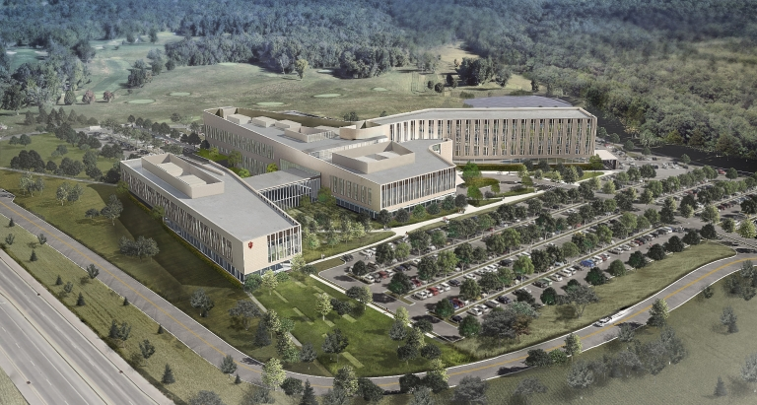Fencing now surrounds a large tract of empty land bordering the IU golf course, scheduled to become the home for a new regional academic health campus. What will the new campus look like? When will construction begin? When will it end? What will it do that is different from the old hospital? Questions abound. Retirees will gather Jan. 10 at 2 p.m. to hear the answers from the man who knows: **Matt Bailey**, president of IU Health South Central Region.

Bailey has more than 30 years experience in community-based health care. Coming to Bloomington as president and CEO of IU Health West Hospital in Avon, he succeeded Mark Moore as president in 2016. Bailey has an undergraduate degree from IU and a master’s of health administration from the University of Minnesota. He is a Fellow of the American College of Healthcare Executives.

The campus will have two components. The IU Health medical facility comprises five floors and 620,000 square feet. The academic facility, for health science education and research, measures 115,000 square feet. The outpatient portion of the medical facility will include a comprehensive cancer center, surgical suites, a diagnostic center, and specialist physician offices.

“This new campus is a really big deal,” says **Bill McGregor**, IURA board member and SPEA professor emeritus. “The health service sector comprises more than one-sixth of the Monroe County economy. The IU Health group, with more than 2,200 employees, is the county’s third largest employer after IU, with more than 9,700 people, and Cook Group with 4,500 employees.”

**Holiday lunch offers fellowship, hope**

**Brian Paulsen**, director of choirs at Edgewood High School, invoked Stevie Wonder’s 1967 “Someday at Christmas” when introducing the musical program at the IURA holiday luncheon Dec. 13: “Someday at Christmas there’ll be no wars. Someday all our dreams will come to be – maybe not in time for you and me, but someday at Christmastime.”

Thanks to planning by **Carol Stokes**, **Doug Porter**, **Mary Ellen Anderson**, **Jan Malinovsky**, and **Gail Londergan**, retirees enjoyed a delicious luncheon catered by Cynthia Moriarty, with music by the award-winning Music Warehouse, Edgewood High School’s show choir.

**Ralf Shaw** shared some photos from the event:

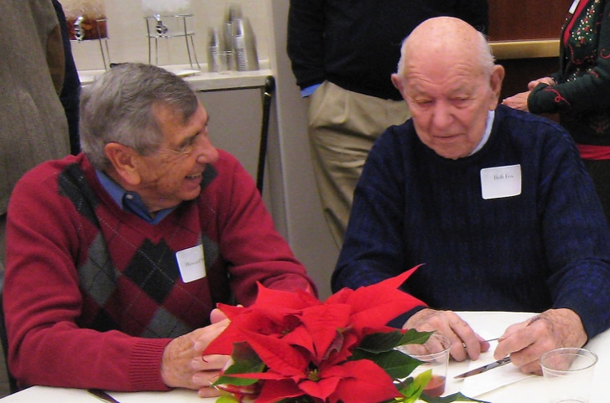**Howard Mehlinger and Bob Fox share some memories.**

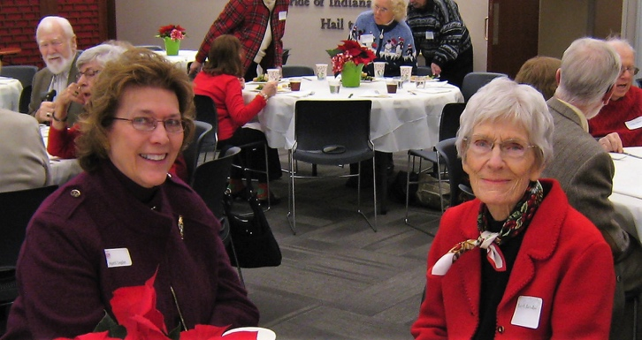**April Legler and Lucy Jacobs enjoy the holiday spirit.**

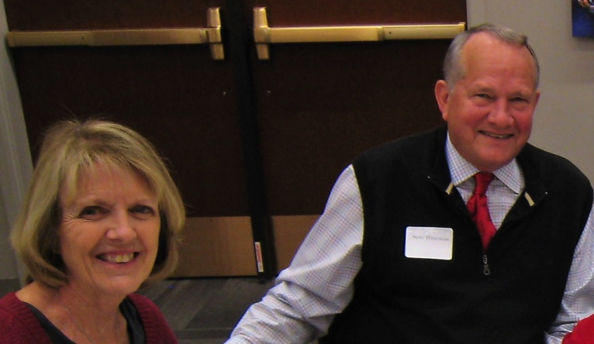**The holiday program had special significance for Janet and Steve Hitzeman, who met in the ‘60s in the swing choir at Concordia Lutheran High School in Fort Wayne.**

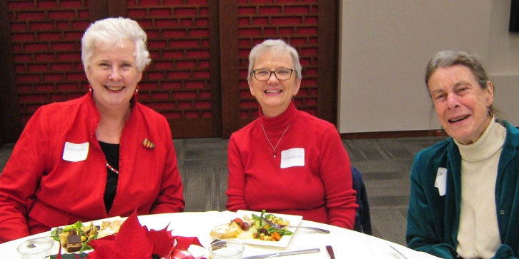

**Friends for several decades, Judy Schroeder, Glenda Murray, and Martha Wailes reunite.**

**Kate Kroll, Mary Rose, and Doris Wittenberg are among those in line for delicious cuisine at the buffet table.**

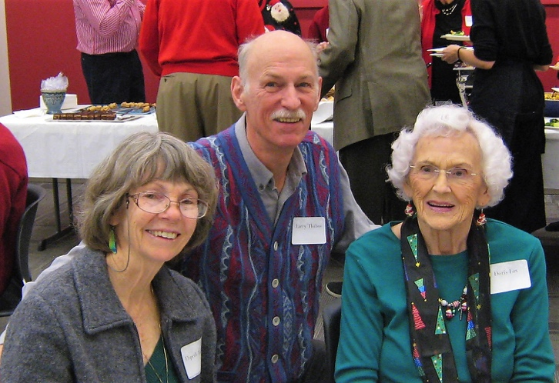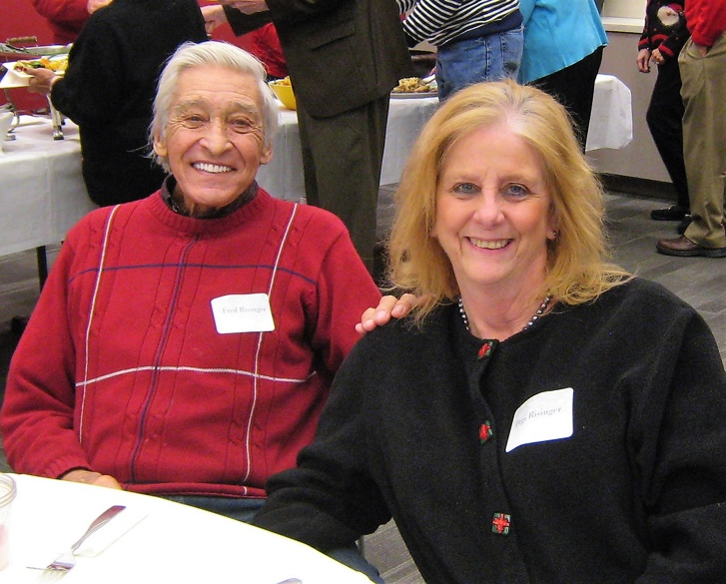**Above, Elspeth and Larry Thibos join Doris Fox, their Windsor Drive neighbor, while Fred and Pegi Risinger bask in the season of joy.**

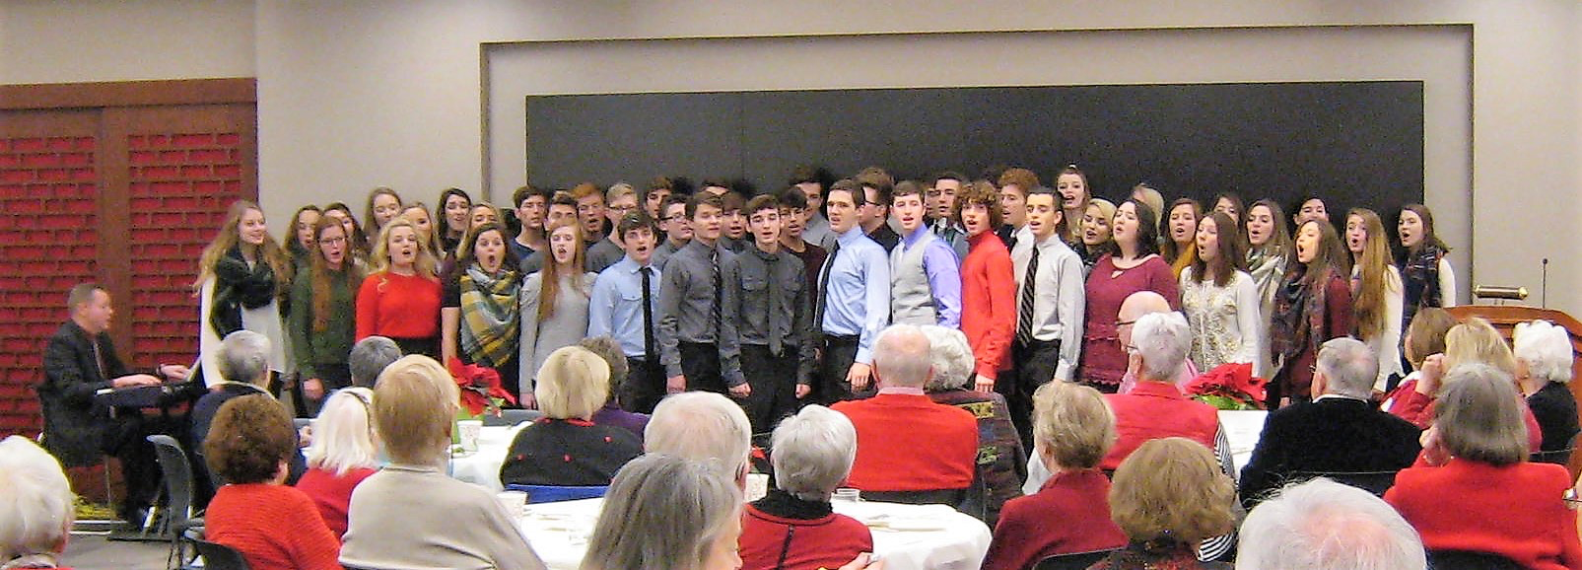

**Edgewood High School’s Music Warehouse will represent Indiana in the Show Choir America competition in Orlando, Fla.**

**Retirees help United Way help others**

In keeping with the holiday’s spirit of cheer, **Harriet Pfister** had good news to share with the approximately 80 retirees attending the Dec. 13 luncheon. As of that date, retirees had reached 99.78 percent of their 2018 goal in pledges to United Way: $209,548 toward $210,000. **Eileen Schellhammer** is sending out gentle reminders to those who have not yet made their pledges, Harriet said, and “we appreciate very much your generosity.”

Although he couldn’t be present at the luncheon, retirees paid tribute to **Wain Martin** with a rousing rendition of his “Go Retirees” cheer.

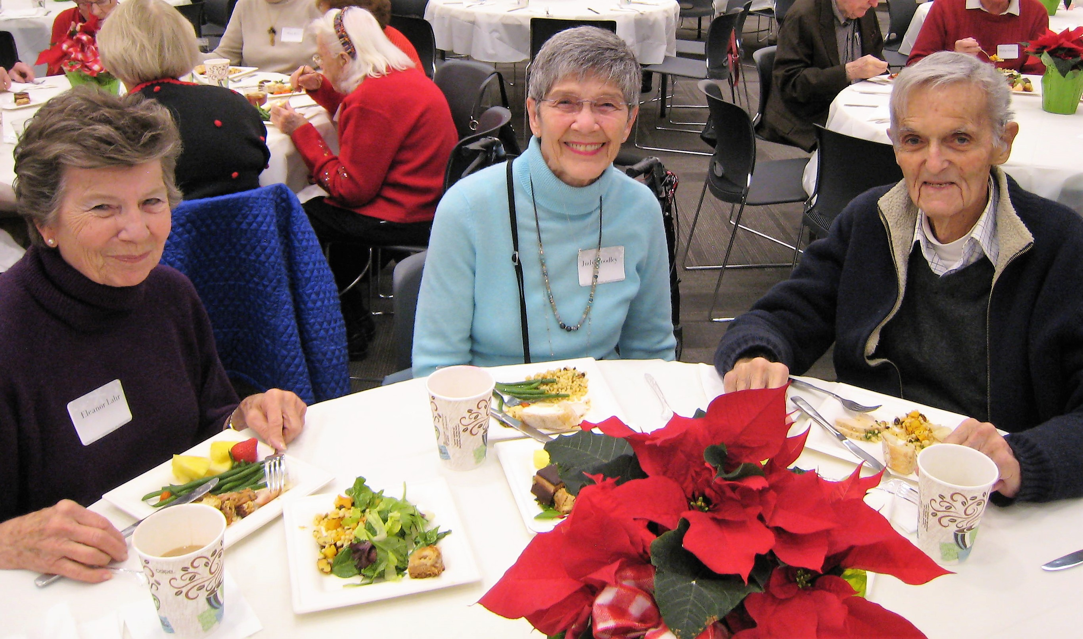

**Eleanor Lahr and Judy and Bob Woodley have a history of ballroom dancing and royal weddings.**

**Put these dates on your 2018 calendar**

Here are future dates for IURA festivities:

* Feb. 14 at 2 p.m., **Joe and Ruth Miller**, the Peace Corps in perspective
* April 11 at 2 p.m., physicist **Ben Brabson**, climate change
* May 9 at 5 p.m., dinner at Meadowood, with **Charlie Jesseph**, guitar

Note that the IURA does not meet in March and there is no newsletter in February.



**IURA board member Mary Ellen Anderson, at left, is radiant in red, while Carol Reynolds and Doris Burton are festive in holiday attire.**

**IU Retirees Association Nonprofit Org.**

**P.O. Box 8393 U.S. Postage PAID**

**Bloomington, IN 47407-8393 Bloomington, IN**

**Permit No. 2**

**Emeriti House, University Club**

For information about the programs of the Emeriti House and the University Club, our partner organizations, see

<http://www.indiana.edu/~emeriti> and

<http:///www.indiana.edu/~uclub>.

**Here’s your membership directory**

Dues-paying members of the IURA are receiving a membership directory by mail with their December *Newswatch*. **Doris Wittenburg**, IURA database manager, compiled the directory, which contains information in the IURA’s 421 members.

This year, for the first time, couples with different last names are listed under both last names. Telephone numbers and email addresses appear only for people who included them with their membership form.

Because the directory is for members only, it is not being distributed in electronic form. It is being mailed with the newsletter, even to those who have requested email delivery of *Newswatch*. Email delivery will begin with the January issue. Address corrections should be sent to Doris at [dwittenb@indiana.edu](mailto:dwittenb@indiana.edu).

Editor **Judy Schroeder** writes *Newswatch* eight times a year. For comments or corrections, please contact her at [jschroed@indiana.edu](mailto:jschroed@indiana.edu).

As a special holiday treat, the IURA board has authorized funds to print this issue in color.

**More photos from the luncheon**

**are posted on**

**the IURA website.**