NEWSWATCH



**Vol. 2017-2018 No. 1 August 2017**

**________________________________________________________________________________­­­­­­__**

**Next meeting: 11:45 a.m., Wednesday, Sept. 13**

**Peterson Room, Showalter House, IU Foundation, SR46 Bypass**

**Welcome! Or welcome back!**

Welcome back to returning members of the IU Retirees Association! As another academic year begins, we look forward to your “re-upping.”

Welcome to prospective members. This issue of *Newswatch* is being mailed to 153 newly retired faculty and staff. We invite you to join us. Dues are modest ($15 for individuals, $20 for couples), and our meetings offer an opportunity to exchange ideas, information, and friendship.

The Retirees Association provides a voice for retirees in their continuing relationship with Indiana University. The organization is entirely self-funded and receives no university support, although the IU Foundation generously provides meeting space at no charge.

Please return the form on the back of the letter from IURA President **Joanie Curts**, together with your membership check.

**September to feature bicentennial**



When the IU Retirees Association meets for its Sept. 13 luncheon at the IU Foundation, the focus will be on IU’s forthcoming bicentennial. In this first meeting of the new academic year, retirees will hear from **Kelly Kish**, deputy chief of staff in the President’s Office and bicentennial director. She will provide an overview of what is being done to involve faculty, staff, students, alumni, and the general public with programs that will celebrate, chronicle, and explore IU’s history and inspire the next 100 years at Indiana University.

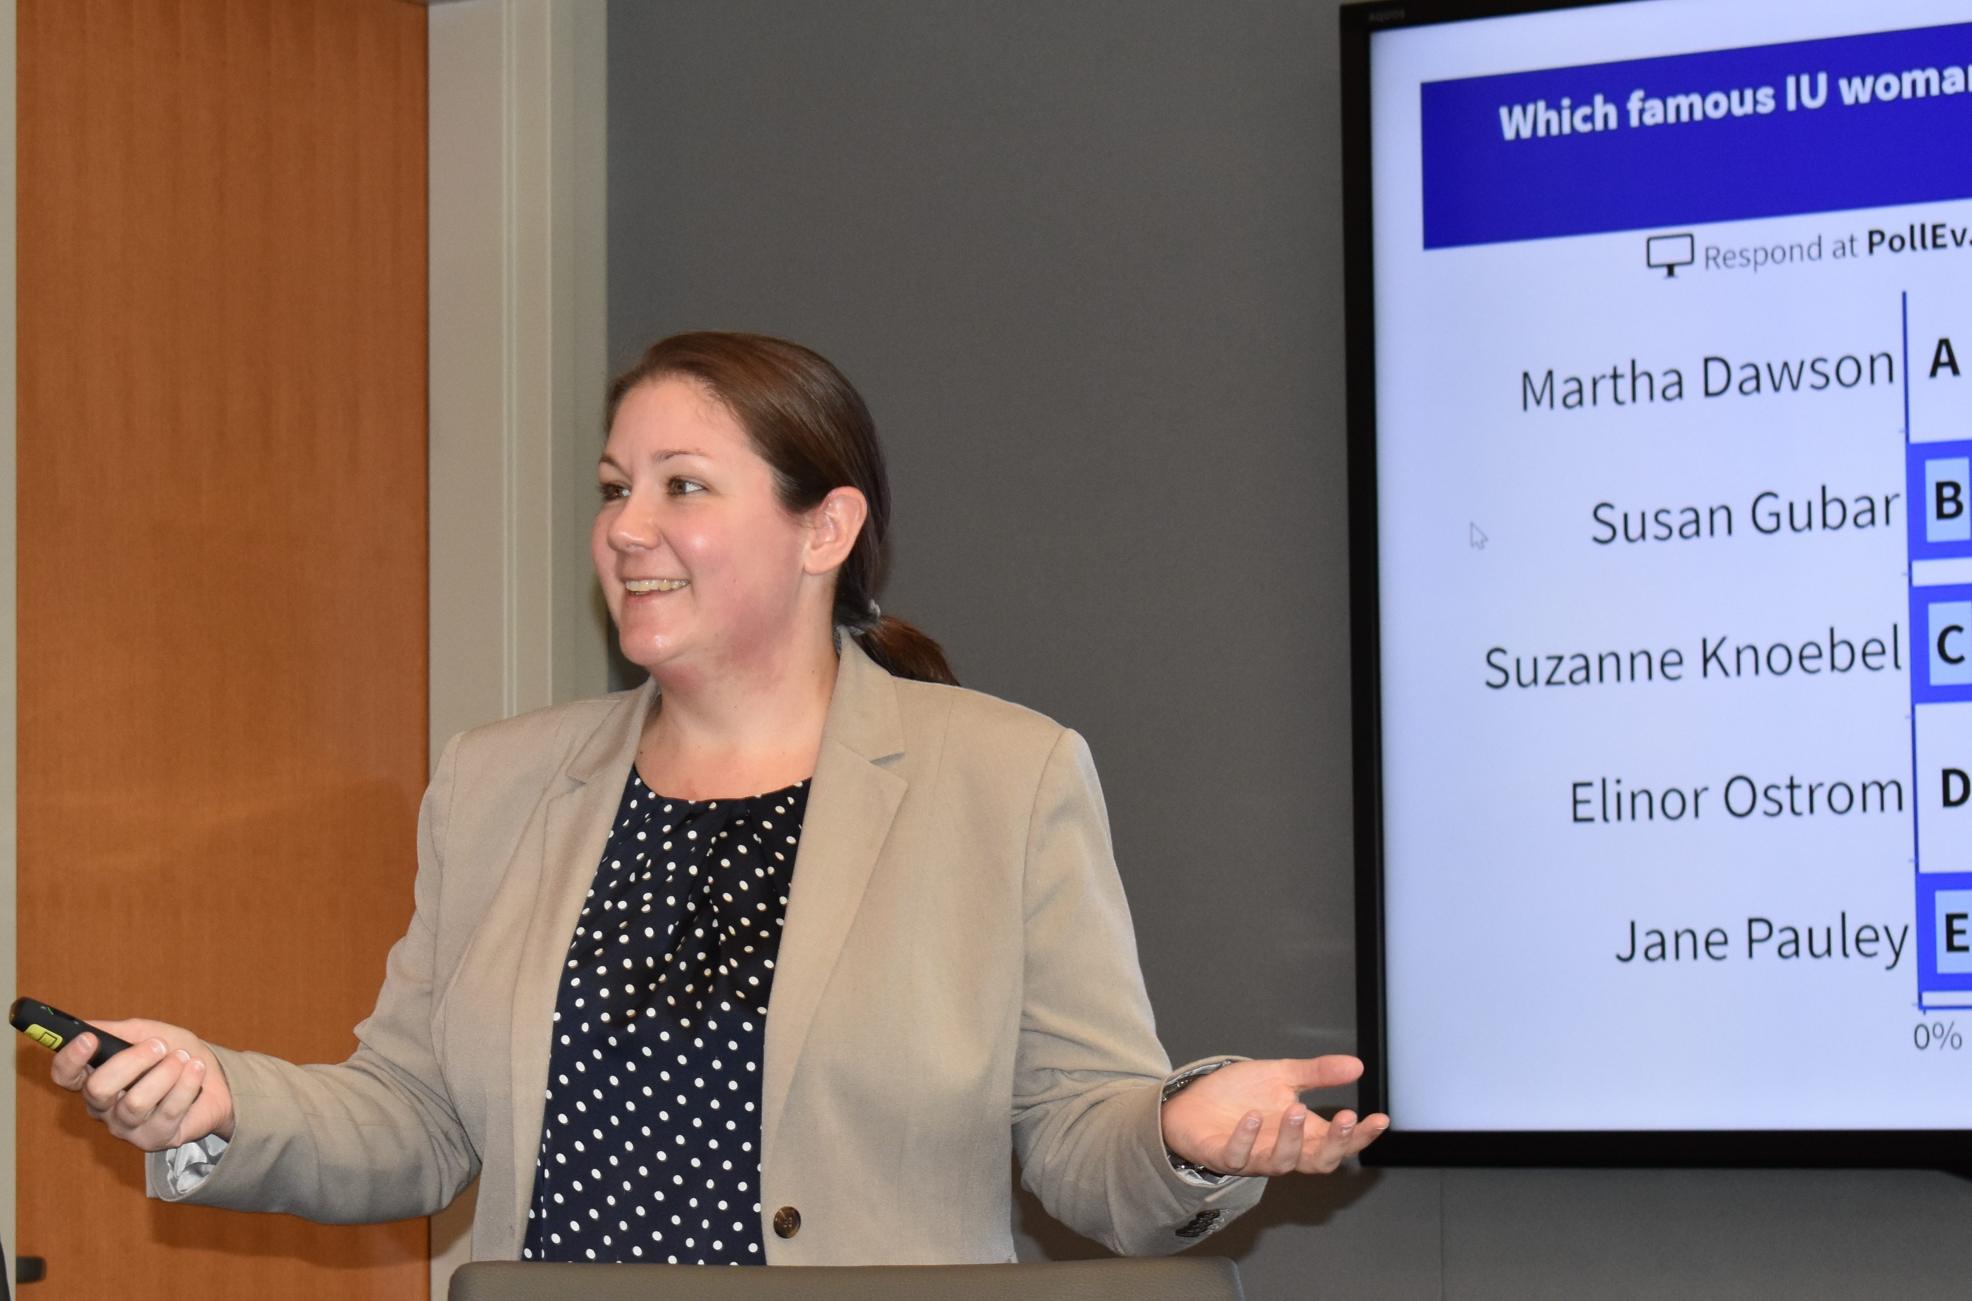Kelly has been at Indiana University for 17 years. She earned a B.A. in Government and Politics/Russian Area Studies from the University of Maryland and a master’s and Ph.D. in higher education administration from IU. The subject of her dissertation was academic freedom. In 2008, she began conceptualizing the university’s bicentennial programming with a group of scholars, librarians, and archivists and initiated the IU Bicentennial Oral History Project. In 2015, she officially assumed the position as director of the IU Bicentennial.

Kelly describes the commemoration as “a multiyear, multi-campus, academically focused program of 25 signature projects, two grant funds, and a student internship program.” For more information, see <https://200.iu.edu/>

Program committee member **Dick McKaig** says, “I recently attended a retreat on the bicentennial planning process and was excited to hear what will be coming our way in the next three years. Many retirees have long histories with IU and are sure to be interested in the bicentennial celebration.”

The buffet table will feature

* Grilled chicken bruschetta;
* Baked penne with artichokes, peppers, tomato, and feta cheese;
* Roasted red potatoes; and
* Roasted vegetable oreganata.

Tables will be preset with a savory salad (mixed greens, cucumber, roasted Roma tomatoes, with balsamic vinaigrette), bread and butter, and a dessert of either a flourless chocolate torte or a lemon syrup cake with lemon cream and blueberries. The caterer is the Indiana Memorial Union.

Cost is $23 per person, and reservations must be received by Sept. 7. Please use the form on the back of letter from President **Joanie Curts**.

Doors open at 11:30 a.m. and the buffet begins at 11:45.

**May potluck features Frog and Toad**

The rain stopped. The sun came out and so did retirees bearing dishes enough to fill four tables in the Peterson Room at the May 10 IURA potluck. After depositing food, retirees enjoyed hors d’oeuvres and wine in the lobby. Reconnecting with old friends and making new ones was so lively that IURA President **Joanie Curts**’ “It’s time to eat” went almost unheard.

Business consisted of announcing that all board members will return, except for **Martha Wailes,** who has chaired the hospitality committee. With stomachs full and business out of the way, retirees let Cardinal take the stage.

 “This may be my final speech as Cardinal artistic director.” With those words Randy White, Cardinal’s founder, walked the audience through the days when the Buskirk-Chumley was first renovated and no regular live theater was offered. Today Cardinal Stage brings 30,000 to 35,000 people downtown. Reid Henderson and A.D. Weaver, as Frog and Toad, illustrated the talent Cardinal brings to town as they sang and danced “He’ll Never Know.”

Randy’s first Bloomington show, a party for 100 people, was Frog & Toad. It was a hit, inspiring the formation of Cardinal Stage, now the largest arts theater in Southern Indiana. Emphasizing the importance of introducing children to theater, a special Cardinal program has raised more than $60,000 to cover the cost for children and families who otherwise might not have access to the joy of live theater. Randy described watching children stand transfixed for eight minutes at the end of Lord of the Flies.

A disappointment for Randy was lack of control of building space. The placement of the orchestra and sound quality, both huge issues, were out of his hands.

Departure of the founder and first director is painful for the company. With necessarily increased costs, such as dividing his 80-hour-a- week job into two, Randy made an impassioned plea for community support, especially in the next 12 to 18 months. **Gabe Gloden** has been chosen as managing director and a new artistic director will be named.

The fall production of Frankenstein will be part of the Indiana University’s Themester, and the season’s family holiday production will be the flying Peter Pan. The show must go on. And we must be there to make it happen.

* *Eleanor Lahr*

**Remembering our friends**

***Twice a year since 2008, in the April and August issues,* Newswatch *memorializes members who have died since the last listing. Because of space limitations, only IURA members can be included. Please notify me*** [*jschroed@indiana.edu*,](mailto:(jschroed@indiana.edu) ***812-332-5057) of any omissions.***

***Judy Schroeder,* Newswatch *Editor***

**Laurence “Larry” Donald Brown died on July 6 in Carbondale, Ill. He was 88. A native of Waynesville, Ohio, Larry served in the Korean War as a member of the 7th Cavalry. He earned a bachelor’s degree at the University of Dayton, a master’s at Miami University, and a doctorate in education at the University of Illinois. In 1962 he joined the faculty of educational psychology at IU’s School of Education, retiring 31 years later. From 1974 to 1980 he was associate dean for academic affairs and later acting dean of the school. Later he directed the Institute for Child Study and chaired the department of counseling and educational psychology. Larry was an avid sailor, woodworker, and world traveler. Marylou, his wife of 60 years, survives.**

**Raymond W. Casati died March 23 in Bloomington. He was 91. Born in Chicago, Ray saw combat during World War II in the submarine service of the U.S. Navy. After the war, he earned a bachelor’s degree in architecture from the Illinois Institute of Technology. In 1950 he joined the IU staff as a draftsman for two years. After a brief stint at an Indianapolis architectural firm, he returned to IU in 1955, eventually becoming assistant vice president and University Architect. In this capacity he supervised the planning and construction of buildings on the Bloomington campus and assisted in the creation of the regional campuses. Ray retired in 2008. In 2009 the conference room of the Service Building at 1800 N. Range Rd. was named in his honor.**

**Frederick Barton Churchill died July 22 in Hanover, N.H. He was 84. Born in Belmont, Mass., Fred earned his undergraduate degree in biology at Harvard University. After service in the Army, he earned a master’s in history at Columbia University and a Ph.D. in history of science at Harvard. In 1967 he joined IU’s new department of history and philosophy of science, later becoming department chair. His numerous articles on heredity, development, and evolution included a 2002 study on the evolutionary ethics of Alfred C. Kinsey. In 2015 Harvard University Press published Fred’s biography of German biologist August Weisman. Fred enjoyed nature, hiking, and birding and supported the activities of the Sassafras Audubon Society and the Sycamore Land Trust. He is survived by his wife of 36 years, Sandra, retired director of staff for the School of Education. A celebration of Fred’s life will be held Oct. 7 at 2 p.m. at the Unitarian Universalist Church.**

**Peggy McIntyre Petranoff died July 25 in Bloomington. She was 90. Peggy grew up in Indianapolis and graduated from the IU School of Nursing in 1947. For more than 55 years she was a nurse at Bloomington Hospital, retiring in 1992 as director of nursing. She was an active member of First United Church. Peggy enjoyed traveling with her husband, Bob, longtime member of the radio and TV department and the IU News Bureau. They were married 68 years before Bob’s death on Jan. 11.**

**Robert Howard Shaffer died April 21 in New Smyrna Beach, Fla. He was 101. Born in Delphi, Ind., Bob graduated from DePauw University, where he was quarterback of the undefeated football team in 1933. He earned his master’s degree in guidance from Columbia University and his Ph.D. in higher education from New York University. An Eagle Scout, Bob worked with the Boy Scouts of America in New York City for five years before beginning in 1941 a 40-year academic career at IU that was interrupted only by service in the U.S. Army during World War II. Director of the student personnel administration program, he was elected the first president of the newly formed American Personnel and Guidance Association in 1951. As dean of students from 1955 to 1968,** he was instrumental in the creation of the counseling, veterans’ affairs, and international services offices**. On his return to the School of Education, Bob established the graduate program in higher education and student affairs, which annually gives the Robert H. Shaffer Alumni Award to an outstanding graduate. The IU Class of 1967 created the Robert H. Shaffer Chair in the College of Arts and Sciences in his honor.** Bob was editor of the *NASPA Journal* and vice president of NASPA: Student Affairs Administrators in Higher Education, which annually confers the Robert H. Shaffer Award for Academic Excellence. **DePauw and IU both awarded him LLD degrees.** Joye Coy Shaffer, his wife of 27 years, survives. A Bloomington celebration of Bob’s life will be held Oct. 21 at 1:30 p.m. at the University Club.

**IU Retirees Association Nonprofit Org.**

**P.O. Box 8393 U.S. Postage PAID**

**Bloomington, IN 47407-8393 Bloomington, IN**

**Permit No. 2**

**Clinton Herbert Strong died July 4 in Bloomington. He was 88. A native of Waukesha, Wis., he graduated from Wisconsin State College at La Crosse with a bachelor’s in physical education. After serving in the U.S. Army during the Korean War, he earned his master’s and Ph.D. degrees at the University of Iowa. Clint taught at Western Illinois University and East Carolina College before coming to IU in 1969 to join the faculty of the department of physical education, later the department of kinesiology. He retired in 1992. For several years he was a member of the education committee of the U.S. Olympic Committee and was president of Phi Epsilon Kappa, the professional fraternity in his field. Clint was active with the American Legion, the VFW, AMVETS, and St. Charles Borromeo Catholic Church. Ann, his wife of nearly 62 years, survives.**

**Frances Goins Wilhoit died July 22 in Bloomington. She was 76. A native of Greensboro, N.C., she earned her bachelor’s degree in journalism and a master’s degree in library science at the University of North Carolina. She moved to Bloomington in 1967 and became head of the IU journalism library and assistant professor of journalism in 1975. She served as collection development officer and personnel officer for the IU Libraries. In 1989 she and a colleague received the John Cotton Dana Award from the American Library Association for their Indiana Newspaper Project, to archive and preserve Indiana newspapers. In 1996 she received the Eleanor Blum Distinguished Service to Research Award from the Association for Education in Journalism and Mass Communication. Fran was active with the League of Women Voters and an enthusiastic outdoorswoman before Alzheimer’s disease took its toll. She is survived by her husband of nearly 54 years, Cleve, professor emeritus of journalism.**

**A peek at the future: coming attractions**

https://www.exchange.iu.edu/owa/14.2.247.5/themes/resources/clear1x1.gifhttps://www.exchange.iu.edu/owa/14.2.247.5/themes/resources/clear1x1.gifIfkiesling

Here are some dates for your calendar:Thanks you Dick I think that is a good suggestion about listing topics. It may generate some more ideas. Thank you and your cmmittee for getting this going. I'm out of town July 12 until July 19 but am accessible at leat by cell phone 812-325-4348 and infrequently

* Thu 7:37 AM
* Oct. 11 at 2 p.m., **Rob Stone**, M.D., on health care
* Nov. 8 at 2 p.m., **Robin Reynolds,** H.R. program on retiree benefits
* Dec. 13, holiday luncheon
* Jan. 10 at 2 p.m., CEO **Matt Bailey,** update on IU Health Bloomington Hospital
* Feb. 14 at 2 p.m., TBA
* April 11 at 2 p.m., physicist **Ben Brabson** on climate change
* May 9 at 5 p.m., dinner at Meadowood

**About this newsletter**

Founded in 1975 as the IU Annuitants Association, the IURA welcomes all retired faculty and staff and their spouses or partners.

*Newswatch* is published eight times each year, August through April, except for February. To correct your address or be removed from the list, please contact database manager **Doris Wittenburg**, [dwittenb@indiana.edu](mailto:dwittenb@indiana.edu). Send comments or corrections to *Newswatch* editor **Judy Schroeder**, [jschroed@indiana.edu](mailto:jschroed@indiana.edu).