NEWSWATCH
Vol. 2015-16 No. 5 December 2015
__________________________________________________________________________________

Next meeting: 2 p.m., Wednesday, January 13, 2016
Kelley Dining Room, DeVault Alumni Center, 1000 E. 17th St.

Historian Madison to inaugurate retiree celebration of Indiana’s bicentennial
Retirees will kick off 2016 with a program dedicated to Indiana’s bicentennial. Jim Madison, Thomas and Kathryn Miller Professor Emeritus of History, will distill 200 years of history when the IU Retirees Association meets at the DeVault Alumni Center on Jan. 13 at 2 p.m.

Jim began teaching Indiana history courses at IU in 1976. In 1982, under the auspices of the Indiana Historical Society, he published his first history of the state, Indiana Through Tradition and Change: A History of the Hoosier State and Its People, 1910-1945. In 1986 he published The Indiana Way: A State History.

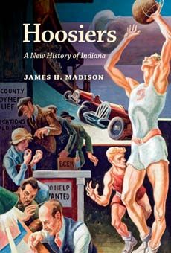A lot of history has happened since 1986, and recent research and perspectives have illuminated the past in new ways. Jim, therefore, created what the subtitle accurately describes as “a new history of Indiana.” His award-winning Hoosiers appeared in 2014. Lee Hamilton describes it as “remarkable and easily readable.” Jim is a member of the Indiana Bicentennial Commission and serves on the boards of Indiana Humanities and the Indiana Historical Society.

Parking is available, free of charge, in the lot directly opposite the DeVault Alumni Center on 17th Street.
On the road with Indiana history

When we take road trips, I read to my husband while he drives. In July, I cashed in my birthday gift – three shows on Broadway. The book I chose for our drive to New York was Jim Madison’s Hoosiers. Our son-in-law, who has lived his entire life in Missouri, was with us, and neither my husband nor I is a native Hoosier. A history of Indiana, therefore, was an unlikely choice. But I had begun the book on a shorter road trip to Missouri earlier that month, and I wanted to get beyond the early pioneers.

All three of us found the book fascinating. Jim writes beautifully, and his ability to synthesize made us aware that every sentence could be expanded to a paragraph, every paragraph to a page. My reading was interrupted multiple times as we discussed the relevance of a historical event to the latest headlines. By the time we were back in Bloomington, we agreed we could have chosen no better road companion than Jim Madison. You won’t want to miss this special bicentennial program on Wednesday, Jan.13.
– J.S.

Our sympathy to IURA webmaster Suzann Owen on the death of her husband, Kent, on Dec. 5. An obituary will appear in Newswatch in April 2016.

“Ah, but a man’s reach should exceed his grasp”: new theme for United Way?

Did Robert Browning have it right? Has the IURA overreached? As of Dec. 9, retirees had attained only 76 percent of their $145,000 goal for 2016 United Way pledges. Although the number of donors is down compared to last year (129 to 137), the number who have pledged $1,000 or more is up, 52 compared to 47. For several years the IURA has met or surpassed its United Way goal.

If you haven’t made your commitment yet, please be sure to specify IU Retirees Association as your giving unit. Historically the amount pledged by IU retirees has made up 10 percent of the total raised by United Way.
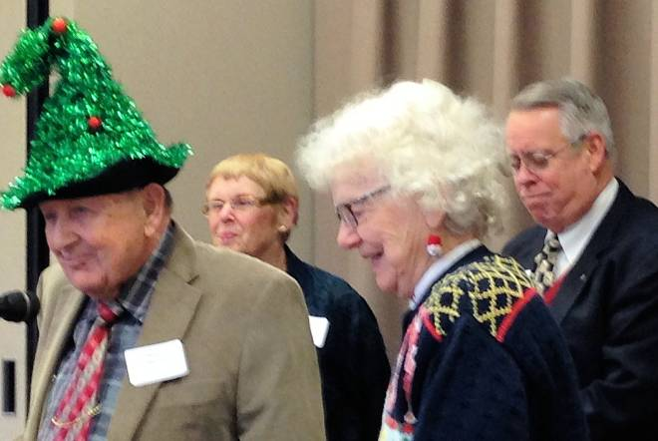
In this photo from 2014, longtime IURA United Way committee members Wain Martin, Doris Burton, and Harriet Pfister give their report. IURA Immediate Past President John Hobson, at right, presides.

Emeriti House, University Club: Partners

For information on the programs of the Emeriti House and the University Club, see www.indiana.edu/~emeriti and www.indiana.edu/~uclub.

Toes tap, hands clap at holiday party

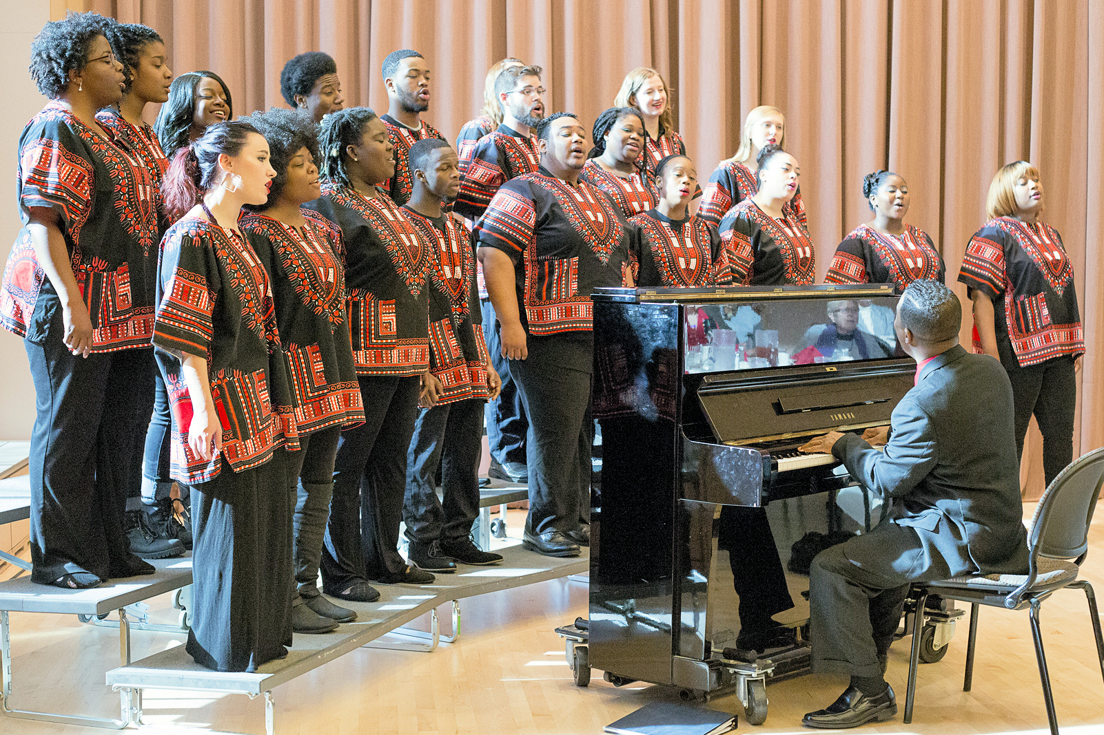The African American Choral Ensemble sang for retirees Dec. 9. Photo by Sarah Baghdadi.

“Your labor has not been in vain. Your legacy is what we live into and live up to,” Raymond Wise, the director of the African American Choral Ensemble, told retirees who gathered for their holiday luncheon on Dec. 9 at the Neal-Marshall Black Culture Center.

Dr. Wise tied the chorus’s repertoire directly to the audience. “Many spirituals speak of a place of freedom,” he said. “That was the desire of slaves, and retirees have reached that destination.”

After the Civil War, Dr. Wise explained, many what we now call Historically Black Universities looked for ways to raise much needed funds. Fisk University in Nashville, Tenn., offered classical music concerts, but had limited success. In the 1870s, appearing before Congregationalists in Oberlin, Ohio, the Fisk Jubilee Singers departed from the classical repertoire and sang spirituals. The audience responded with generous contributions, and the concert spiritual, which used sheet music, developed. The African American Choral Ensemble’s rendition of the spiritual “I’ve Been ’Buked and I’ve Been Scorned” contrasted with the concert spiritual “I Open My Mouth to the Lord and I Won’t Turn Back.”

The high-energy group swayed and clapped as they sang, accompanied by Dr. Wise. “Students are having stress at this time, with finals coming,” the director told retirees, “and some want to give up.” The lyrics of the gospel song “You Can Make It” serve to inspire both students and retirees, he said. “When friends and family are gone and it seems you’re alone and on your own, hold up your head and walk on through the hurt and pain,” the chorus sang.

Gospel music, Dr. Wise informed the audience, is a collective art. He invited retirees to join in the exuberant version of “Joy to the World” that ended the program.

When John Hobson introduced the group, he explained that the African American Choral Ensemble is one of three performing arms of the African American Arts Institute, the others being the IU Soul Review and the African American Dance Company.

The choral ensemble is celebrating its 40th anniversary. On March 6 at 4 p.m. at the Second Baptist Church, the chorus will reprise the program of its first performance 40 years ago, with founding director Michael Gordon as a special guest. The 40th anniversary concert, which will include chorus alumni as well as current members, is scheduled for April 30 at 8 p.m. in the Buskirk-Chumley Theater.

Terry’s catered the luncheon, and one lucky person at each table was the recipient of the poinsettia that served as the centerpiece. Hospitality committee chair Harriet Pfister arranged the luncheon, assisted by committee members Carol Stokes and Martha Wailes.

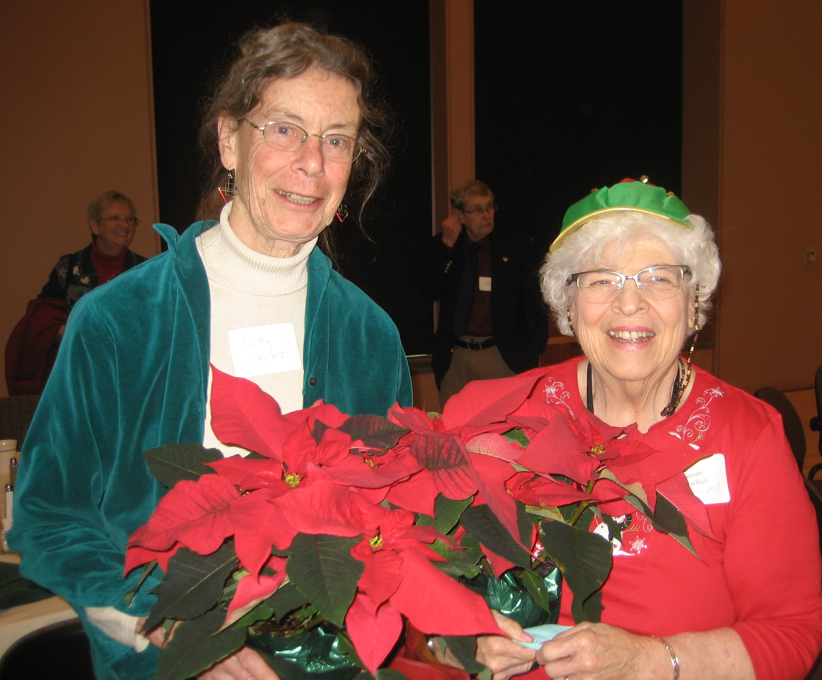

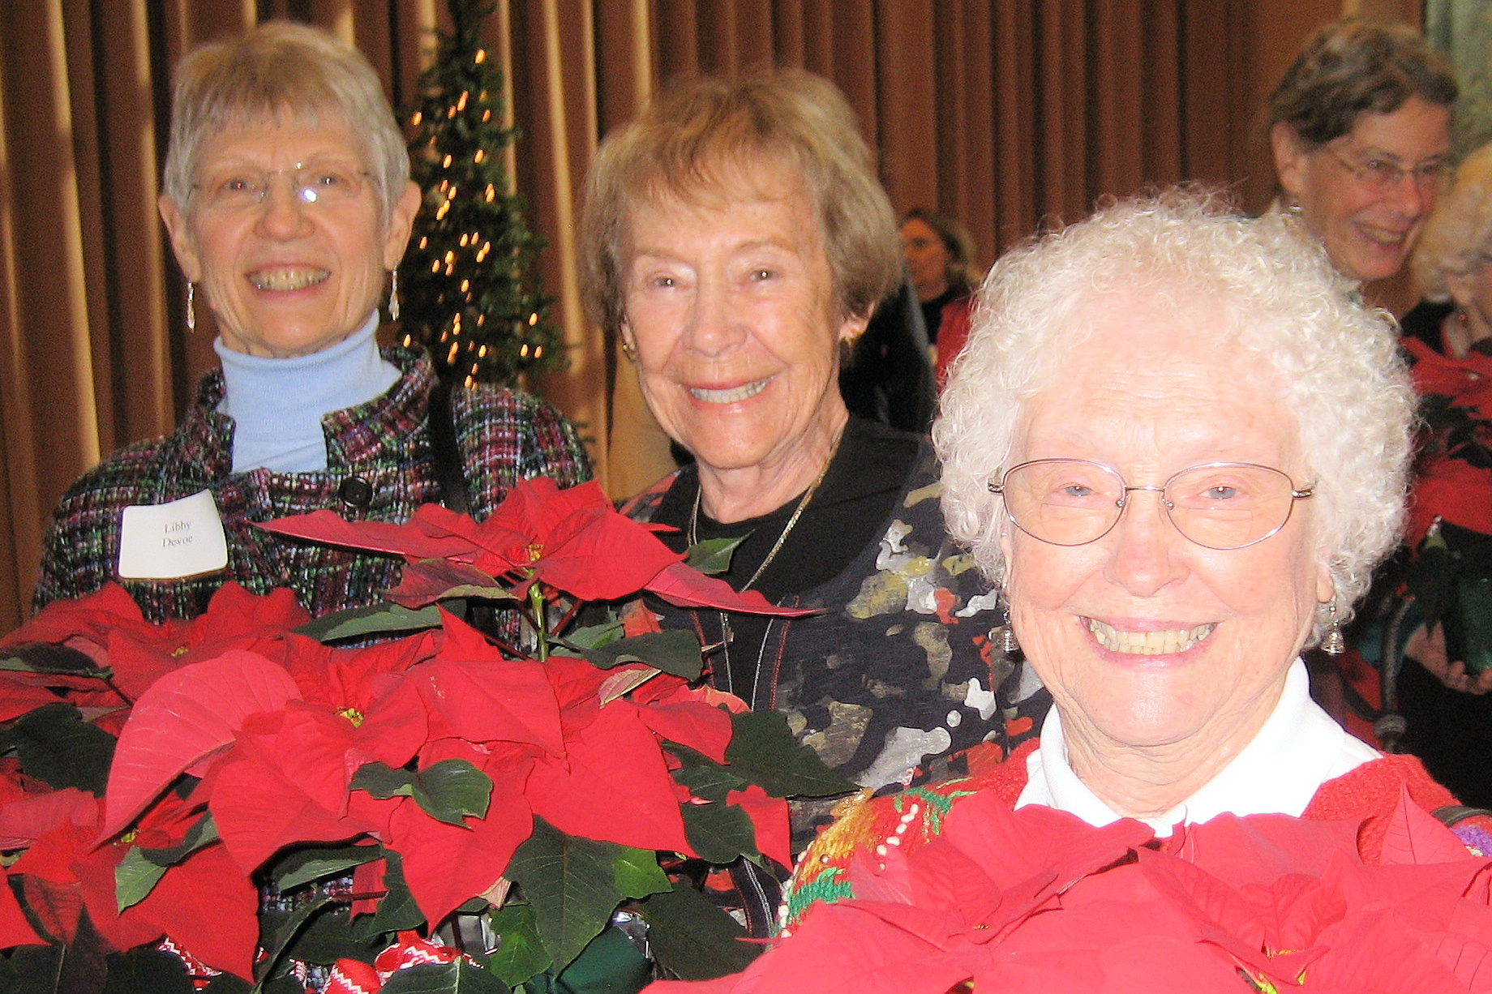
Some lucky people took home poinsettias after the Dec. 9 holiday luncheon. Top photo: Martha Wailes and Susan Voelkel. Below, from left: Libby DeVoe, Marion Bankert Michael, and Joann Dodd.

NIH website serves older adults

IURA President Jo Daron has requested that the following item from The Gray Hawk, the newsletter of the University of Iowa Retirees Association, appear in Newswatch. The article is reprinted with the kind permission of Ken Starck, The Gray Hawk’s editor.
The National Institute on Aging and the National Library of Medicine, which are parts of the National Institutes of Health (NIH), developed a website for older adults. The website, http://nihseniorhealth.gov, was developed for age-related health information for older adults and was tested with adults age 60 to 88 to ensure that it was easy for them to see, understand, and navigate.

The website’s senior-friendly features include dark font against a light background, large sans-serif font, ability to enlarge text and change the contrast, and easy-to-click links including search results. Health topics include general background information, open-captioned videos, quizzes, and frequently asked questions (FAQs). New topics are added to the site on a regular basis.

The short health videos offer up-to-date medical information tips for healthy living and stories of older adults who are coping with diseases or conditions of aging. The A– Z listing of health topics includes an explanation of the topic, causes, symptoms, and diagnosis, possible treatments, and FAQs. A small sample of topics listed include sleep and aging, balance problems, dry eye, dental health, skin care, and end of life. The website is just another resource for seniors.

Here’s your membership directory!

Dues-paying members of the IURA are receiving a membership directory by mail with their December Newswatch. Doris Wittenburg, IURA database manager, compiled the directory, which contains information on the IURA’s 379 members. Telephone numbers and email addresses appear only for people who included them with their membership form.

The directory is distributed only to members. An additional 108 people are receiving the newsletter without the directory. These include newly retired individuals who are receiving a one-year complimentary membership, as well as other Big Ten retiree associations and a number of Indiana University offices.

To correct your address or to be removed from the list, please contact Doris at dwittenb@indiana.edu. For comments about or corrections to the newsletter, please contact Newswatch editor Judy Schroeder, jschroed@indiana.edu.

IU Retirees Association Nonprofit Org.
P.O. Box 8393 U.S. Postage PAID
Bloomington, IN 47407-8393 Bloomington, IN
Permit No. 2

Gleaned from the catalogs

Among the products advertised in the gazillion catalogs that arrived in our mailbox are two T-shirts for retirees on your list:
▪ The best thing about the good old days was that I wasn’t good and I wasn’t old.
▪ So when is this “old enough to know better” supposed to kick in?

We get by with help from our friends

Founded in 1975 as the IU Annuitants Association, the IU Retirees Association welcomes all retired faculty and staff and their spouses. The IURA receives no university funding and operates entirely on membership donations.

At this time of the year, however, we give particular thanks for the gifts we receive from various IU entities:
- The university allows us to mail materials with the university permit.
- The IU Foundation and the IU Alumni Association host our meetings free of charge.
- University Human Resources provides us with lists of new retirees so that we can introduce them to the IURA. Karen Hill is HR’s liaison to the IURA. She can be reached at kashill@iu.edu, 812-856-4459.
A list of retiree benefits is posted on the IURA website: http://www.indiana.edu/~iura.

Put these dates on your 2016 calendar

- Jan. 13 at 2 p.m., historian Jim Madison on Indiana’s 2016 bicentennial
- Feb. 10 at 2 p.m., WFIU’s longtime jazz host Dick Bishop
- April 13 at 2 p.m., political scientist Marjorie Hershey on the 2016 elections
- May 11 at 5 p.m., the annual pitch-in dinner, with program to be announced

Because of construction going on at the IU Foundation, the first three meetings of 2016 will be at the DeVault Alumni Center, 1000 E. 17th St. We hope to be able to return to the Foundation for our May meeting. The IURA does not meet in March, and there is no newsletter in February.

